GATE question papers: Civil Engineering 2003 (CE)
Q.1 – 1.30 CARRY ONE MARK EACH.

1. Given Matrix [A] =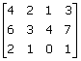, the rank of the matrix is
(a) 4 (b) 3 (c) 2 (d) 1

2. A box contains 10 screws, 3 of which are defective. Two screws are drawn at random with replacement. The probability that none of the two screws is defective will be
(a) 100% (b) 50% (c) 49% (d) None of these

3. If P, Q and R are three points having coordinates (3,-2,01), (1,3,4), (2,1,-2) in XYZ space, then the distance from point P to plane OQR (O being the origin of the coordinate system) is given by
(a) 3 (b) 5 (c) 7 (d) 9

4. A bar of varying square cross-section is loaded symmetrically as shown in the figure. Loads shown are placed on one of the axes of symmetry of cross-section. Ignoring self weight, the maximum tensile stress in N/mm² anywhere is
(a) 16.0 (b) 20.0 (c) 25.0 (d) 30.0

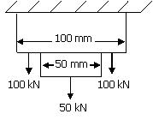

5. Muller Breslau principle in structural analysis is used for
(a) drawing influence line diagram for any force function
(b) writing virtual work equation
(c) super-position of load effects
(d) none of these

6. The effective length of a column in a reinforced concrete building frame, as per IS: 456-2000, is independent of the
(a) frame type i.e., braced (no sway) or un-braced (with sway)
(b) span of the beam
(c) height of the column
(d) loads acting on the frame

7. A curved member with a straight vertical leg is carrying a vertical load at Z, as shown in the figure. The stress resultants in the XY segment are
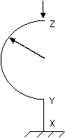
(a) bending moment, shear force and axial force
(b) Bending moment and axial force only
(c) bending moment and shear force only
(d) axial force only

8. The working stress method of design specifies the value of modular ratio, m = 280/ (3 σ_{cbc}), where σ_{cbc} is the allowable stress in bending compression in concrete. To what extent does the above value of m make any allowance for the creep of concrete?
(a) No compensation (b) Full compensation
(c) Partial compression (d) The two are unrelated

9. In the design of lacing system for a built-up steel column, the maximum allowable slenderness ratio of a lacing bar is
(a) 120 (b) 145 (c) 180 (d) 250

10. Which of the following elements of a pitched roof industrial steel building primarily resists lateral load parallel to the ridge?
(a) bracings (b) purlins (c) truss (d) columns

11. Maximum strains in an extreme fibre in concrete and in the tension reinforcement (Fe-415 grade and Es=200 kN/mm²) in a balanced section at limit state of flexure are respectively
(a) 0.0035 and 0.0038 (b) 0.002 and 0.0018
(c) 0.0035 and 0.0041 (d) 0.002 and 0.0031

12. The stiffness K of a beam deflecting in a symmetric mode, as shown in the figure, is
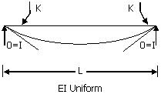
(a)
(b)
(c)
(d)

13. A masonry dam is founded on previous sand having porosity equal to 45% and specific gravity of sand particles is 2.65. For a desired factor of safety of 3 against sand boiling, the maximum permissible upward gradient will be
(a) 0.225 (b) 0.302 (c) 1.0 (d) None of these

14. A double draining clay layer, 6m thick, settles by 30mm in three years under the influence of a certain loads. Its final consolidation settlement has been estimated to be 120 mm. If a thin layer of sand having negligible thickness is introduced at a depth of 1.5m below the top surface, the final consolidation settlement of clay layer will be
(a) 60 mm (b) 120 mm (c) 240 mm (d) None of these

14. A double draining clay layer, 6m thick, settles by 30mm in three years under the influence of a certain loads. Its final consolidation settlement has been estimated to be 120 mm. If a thin layer of sand having negligible thickness is introduced at a depth of 1.5m below the top surface, the final consolidated settlement of clay layer will be
(a) 60 mm (b) 120mm (c) 240 mm (d) None of these

15. A granular soil possesses saturated density of 20 kN/m³. Its effective angle friction is 35 degrees. If the desired factor of safety is 1.5, the safe angle of slope for this soil, when seepage occurs at and parallel to the surface, will be
(a) 25° (b) 23° (c) 20° (d) 13°

16. In a plate load test conducted on cohesionless soil, a 600 mm square test plate settles by 15mm under a load intensity of 0.2 N/mm². All conditions remaining the same, settlement of a 1m square footing will be
(a) less than 15 mm (b) greater than 25 mm
(c) 15.60 mm (e) 20.50

17. A 25 kN point load acts on the surface of an infinite elastic medium. The vertical pressure intensity in kN/m² at a point 6.0 m below and 4.0 m away from the load will be
(a) 132 (b) 13.2 (c) 1.32 (d) 0.132

18. For a two-dimensional irrotational flow, the velocity potential is defined as φ = In(x²+y²). Which of the following is a possible stream function, ψ, for this flow?
(a) tan⁻¹ (y/x) (b) tan⁻¹ (y/x) (c) 2 tan⁻¹ (y/x) (d) 2 tan⁻¹ (x/y)

19. A flat plate is kept in an infinite fluid medium. The fluid has a uniform free-stream velocity parallel to the plate. For the laminar boundary layer formed on the plate, pick the correct option matching Columns I and II.
Column I
P. Boundary layer thickness
Q. Shear stress at the plate.
R. Pressure gradient along the plate.
Column II
1. decreases in the flow direction
2. Increases in the flow direction
3. remains unchanged
Codes:
P Q R

(a) 1 2 3
(b) 2 2 2
(c) 1 1 1
(d) 2 1 3

20. A laboratory model of a river is built to a geometric scale of 1:00. The fluid used in the model is oil of mass density 900 kg/m³. The highest flood in the river is 10,000 m³/s. The corresponding discharge in the model shall be
(a) 0.95 m³/s. (b) 0.100 m³/s. (c) 0.105 m³/s. (d) 10.5 m³/s.

21. Water is pumped from a well tapping an unconfined aquifer at a certain discharge rate and the steady state drawdown (X) in an observation well is monitored. Subsequently, the pumping discharge is doubled and the steady state drawdown in the same observation well is found to be more than double (i.e., more than 2X). This disproportionate drawdown is caused by
(a) well losses
(b) decrease in the saturated thickness of the aquifer
(c) nonlinear flow
(d) delayed gravity yield

22. The vertical hydraulic conductivity of the top soil at certain is 0.2 cm/hr. A storm of intensity 0.5 cm/hr occurs over the soil for an indefinite period. Assuming the surface drainage to be adequate, the infiltration rate after the storm has lasted for a very long time, shall be
(a) smaller than 0.2 cm/hr (b) 0.2 cm/hr
(c) between 0.2 and 0.5 cm/hr (d) 0.5 cm/hr

23. The total irrigation depth of water, required by a certain crop in its entire growing period (150 days), is 25.92 cm. The culturable command area for a distributary channel is 100,000 hectares. The distributary channel shall be designed for a discharge.
(a) less than 2 cumecs (b) 2 cumecs
(C) 20 cumecs (d) more than 20 cumecs

24. The moisture content of soil in the root zone of an agricultural crop at certain stage is found to be 0.05. The field capacity of the soil is 0.15. The root zone depth is 1.1m. The consumptive use of crop at this stage is 2.5 mm/day and there is no precipitation during this period. Irrigation efficiency is 65%. It is intended to raise the moisture content to the field capacity in 8 days through irrigation. The necessary depth of irrigation is
(a) 115 mm (b) 169 mm (c) 200 mm (d) 285 mm

25. The results of analysis of a raw water sample are given below
Turbidity : 5 mg/1
pH : 7.4
Fluorides : 2.5 mg/1
Total Hardness : 300 mg/1
Iron : 3.0 mg/1
MPN : 50 per 100 ml
From the data given above, it can be inferred that water needs removal of
(a) Turbidity followed by disinfection
(b) Fluorides and Hardness
(c) Iron, followed by disinfection
(D) Both (b) and (c)

26. Which of the following sewage treatment methods has inherent problem of odour, ponding, and fly nuisance?
(a) UASB system (b) Activated sludge process
(c) Trickling filters (d) Stabilization ponds

27. From amongst the following sewage treatment options, largest land requirements for a given discharge will be needed for
(a) trickling filter (b) anaerobic pond
(c) oxidation ditch (d) oxidation pond

28. Zero hardness of water is achieved by
(a) lime soda process (b) excess lime treatment
(c) iron exchange treatment (d) excess alum and lime treatment

29. Temperature stresses in concrete pavements may cause the slab to crack. If a slab cools uniformly then the crack will develop at the following locations of the slab
(a) at centre (b) near edges
(c) at corners (d) both (b) and (c)

30. The speed and delay studies on a defined section of highway are conducted by
(a) radar gun (b) traffic counters
(c) moving car method (d) enoscope

Q. 31-90 CARRY TWO MARKS EACH

31. If L defines the Laplace Transform of a function, L [sin (at)] will be equal to
(a) a/ (s²-a²) (b) a/ (s²+a²) (c) s/ (s²+a²) (d) s/ (s²-a²)

32. The Fourier series expansion of a symmetric and even function, ƒ(x) where
ƒ(x) = 1+ (2x/p), – p < x < 0 and
= 1-(2x/p), 0 < x < p
will be
(a) 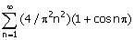 (b) 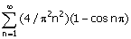
(c) 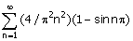 (d) 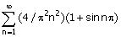

33. A long structural column (length = L) with both ends hinged is acted upon by an axial compressive load, P. The differential equation governing the bending of column is given by
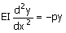
where y is the structural lateral deflection and EI is the flexural rigidity. The first critical load on column responsible for its buckling is given by
(a) p²EI/L² (b) EI/L² (c) 2p²EI/L² (d) 4p²EI/L²

34. In a redundant joint model, three bar members are pin connected at Q as shown in the figure. Under some load placed at Q, the elongation of the members MQ and OQ are found to be 48 mm and 35 mm respectively. Then the horizontal displacement u and the vertical displacement v of the node Q, in mm, will be respectively.

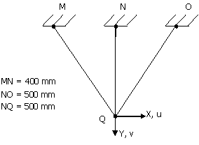

(a) -6.64 and 56.14 (b) 6.64 and 56.14
(c) 0.0 and 59.41 (d) 59.41 and 0.0

35. Top ring beam of an Intze tank carries a hoop tension of 120 kN. The beam cross-section is 250 mm wide and 400 mm deep and it is reinforced with 4 bars of 20 mm diameter of Fe 415 grade. Modular ratio of the concrete is 10. The tensile stress in N/mm²in the concrete is
(a) 1.02 (b) 1.07 (c) 1.20 (d) 1.32

36. A “H” shaped frame of uniform flexural rigidity EI is loaded as shown in the figure. The relative outward displacement between points K and O is
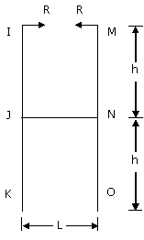
(a) 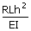

(b) 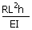

(c) 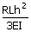

(d) 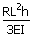

37. A simply supported beam of uniform rectangular cross-section of width b and depth h is subjected to linear temperature gradient, 0º at the top and Tº at the bottom, as shown in the figure. The coefficient of linear expansion of the beam material is α. The resulting vertical deflection at the mid-span of the beam is
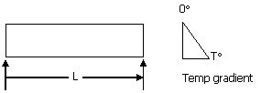

(a) 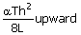 (b) 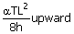
(c) 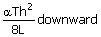 (d) 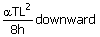

38. A truss, as shown in the figure, is carrying 180 kN load at node L₂. The force in the diagonal member M₂U₄ will be

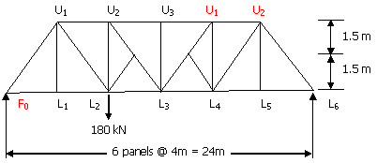

(a) 100 kN tension (b) 100 kN compression
(c) 80 kN tension (d) 80 kN compression

39. A steel portal frame has dimensions, plastic moment capacities and applied loads as shown in the figure. The vertical load is always twice of the horizontal load. The collapse load P required for the development of a beam mechanism is

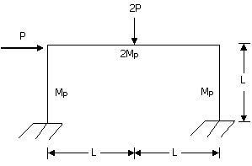

(a) 3M_{p}/L (b) 4M_{p}/L (c) 6M_{p}/L (d) 8M_{p}/L

40. The state of two dimensional stress acting on a concrete lamina consists of a direct tensile stress,
σ_{x} = 1.5 N/mm², and shear stress i= 1.20 N/mm², which cause cracking of concrete. Then the tensile strength of the concrete in N/mm² is
(a) 1.5 (b) 2.08 (c) 2.17 (d) 2.29

41. Group I contains some properties of concrete/cement and Group 2 contains list of some tests on concrete/cement. Match the property with the corresponding test.
Group I
P workability of concrete
Q direct tensile strength of concrete
R bond between concrete and steel
S fineness of cement

Group II
1. cylinder splitting test
2. Vee-Bee test
3. surface area test
4 fineness modulus test
5. pull out test.
Codes:
P Q R S
(a) 2 1 5 3
(b) 4 5 1 3
(c) 2 1 5 4
(d) 2 5 1 4

42. Group I contains some elements in design of a simply supported plate girder and Group 2 gives some qualitative locations on the girder. Match the items of two lists as per good design practice and relevant codal provisions.
Group I
P flange splice
Q web splice
R bearing stiffeners
S horizontal stiffener

Group II
1. at supports (minimum)
2. away from centre of span
3. away from support
4. in the middle of span
5. longitudinally somewhere in the compression flange

Codes:
P Q R S
(a) 2 3 1 5
(b) 4 2 1 3
(c) 3 4 2 1
(d) 1 5 2 3

43. A concrete column caries an axial load of 450 kN and a bending moment of 60 kM m at its base. An isolated footing of size 2m by 3m, with 3m side along the plane of the bending moment, is provided under the column. Centres of gravity of column and footing coincide. The net maximum and the minimum pressures in kN/m² on soil under the footing are respectively.
(a) 95 and 55 (b) 95 and 75 (c) 75 and 55 (d) 75 and 75

44. Group I shows different loads acting on a beam and Group 2 shows different bending moment distributions. Match the load with the corresponding bending moment diagram.

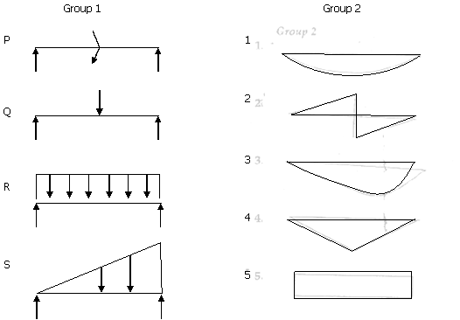

Codes:
P Q R S
(a) 4 2 1 3
(b) 5 4 1 3
(c) 2 5 3 1
(d) 2 4 1 3

45. Compaction of an embankment is carried out in 500 mm thick layers. The rammer used for compaction has a foot area of 0.05 sq. m and the energy imparted in every drop of rammer is 400 Nm. Assuming 50% more energy in each pass over the compacted area due to overlap, the number of passes required to develop compactive energy equivalent to Indian Standard light compaction for each layer would be
(a) 10 (b) 16 (c) 20 (d) 26

46. A braced cut, 5m wide and 7.5m deep is proposed in a cohesionless soil deposit having effective cohesion c’=0 and effective friction angle, f’=36⁰. The first row of struts is to be installed at a depth of 0.5 m below ground surface and spacing between the struts should be 1.5m. If the horizontal spacing of struts is 3m and unit weight of the deposit is 20kN/m³, the maximum strut load will be
(a) 70.87 kN (b) 98.72 kN (c) 113.90 kN (d) 151.86 kN

47. For the soil strata shown in figure, the water table is lowered by drainage by 2m and if the top 2m thick silty sand stratum remains saturated by capillary action even after lowering of water table, the increase in effective vertical pressure in kPa at mid-height of clay layer will be

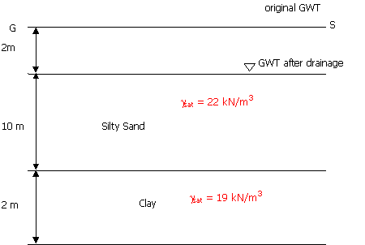

(a) 0.2 (b) 2 (c) 20 (d) 200

48. At a reclamation site for which the soil strata is shown in figure, a 3m thick layer of a fill material is to be laid instantaneously on the top surface. If the coefficient of volume compressibility, m_{v} for clay is 2.2 x 10⁻⁴ m²/kN, the consolidation settlement of the clay layer due to placing of fill material will be

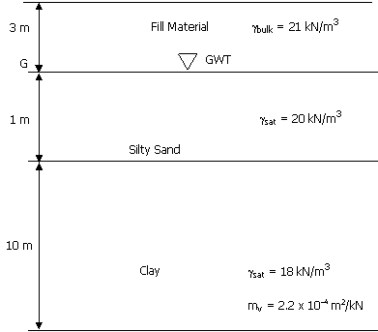

(a) 69.5 mm (b) 139 mm (c) 228 mm (d) 278 mm

49. For the (3 × 3) pile group shown in the figure, the settlement of pile group, in a normally consolidated clay stratum having properties as shown in the figure, will be

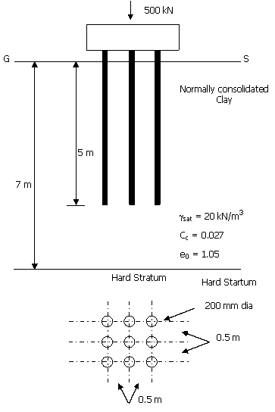

(a) 13.2 mm (b) 12.775 mm (c) 7.345 mm (d) none of these

50. Match the items of the two lists and select the correct answer.

List I (Boring Methods)
P Auger Boring
Q Wash Boring
R Percussion Drilling
S Rotary Drilling
List II (Field Conditions)
1. Below water table in all soil types except hard soils and rocks
2. Large diameter boreholes over 150 mm in size
3. Explorations for shallow foundations and highways
4. Bouldery and gravelly strata
Codes:
P Q R S
(a) 3 1 4 2
(b) 1 2 4 3
(c) 2 3 4 1
(d) 3 1 2 4

51. Match the items of List-I with List-II and select the correct answer.
List I
P Modulus of subgrade reaction
Q Relative density and strength
R Skin friction and point bearing reistance
S Elastic constants

List II
1. Cyclic pile load test
2. Pressure meter test
3. Plate load test
4. Standard penetration test
5. Dynamic cone penetration test

Codes:
P Q R S
(a) 1 3 2 5
(b) 1 2 4 3
(c) 2 5 1 3
(d) 3 4 1 2

52. A horizontal jet strikes a frictionless vertical plate (the plan view is shown in the figure). It is then divided into two parts, as shown in the figure. If the impact loss can be neglected, what is the value ofq?

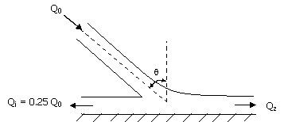

(a) 15° (b) 30° (c) 45° (d) 60°

53. A hydraulic jump takes place in a triangular channel of vertex angle 90⁰, as shown in figure. The discharge is 1m³/s and the pre-jump depth is 0.5 m. What will be the post-jump?
(Take g = 9.81 m/s²)

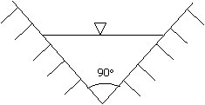

(a) 0.57 m (b) 0.91 m (c) 1.02 m (d) 1.57 m

54. Two pipelines, one carrying oil (mass density 900 kg/m³) and the other water, are connected to a manometer as shown in the figure. By what amount the pressure in the water pipe should be increased so that the mercury levels in both the limbs of the manometer become equal? (Mass density of mercury = 13,550 kg/m³ and g = 9.81 m/s²)
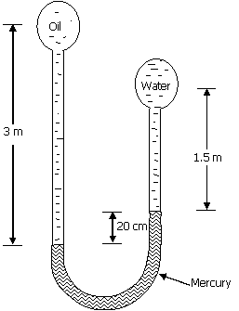

(a) 24.7kPa (b) 26.5 kPa (c) 26.7 kPa (d) 28.9 kPa

55. A solids sphere (diameter 6 mm) is rising through oil (mass density 900 kg/m³, dynamic viscosity 0.7 kg/ms) at a constant velocity of 1 cm/s. What is the specific weight of the material from which the sphere is made? (Take g = 9.81 m/s²)
(a) 4.3 kN/m³ (b) 5.3 kN/m³ (c) 8.7 kN/m³ (d) 12.3 kN/m³

56. While applying the Rational formula for computing the design discharge, the rainfall duration is stipulated as the time of concentration because
(a) this leads to the largest possible rainfall intensity
(b) this leads to the smallest possible rainfall intensity
(c) the time of concentration is the smallest rainfall duration for which the Rational formula is applicable
(d) the time of concentration is the largest rainfall duration for which the Rational formula is applicable

57. While designing a hydraulic structure, the piezometric head at bottom of the floor is computed as 10m. The datum is 3m below floor bottom. The assured standing water depth above the floor is 2m. The specific gravity of the floor is computed as 10m. The datum is 3m below floor bottom. The assured standing water depth above the floor is 2m. The specific gravity of the floor material is 2.5. The floor thickness should be
(a) 2.00 m (b) 3.33 m (c) 4.40 m (d) 6.00 m

58. The plan area of a reservoir is 1 km². The water level in the reservoir is observed to decline by 20 cm in a certain period. During this period the reservoir receives a surface inflow of 10 hectare-meters, and 20 hectare-meters are abstracted from the reservoir for irrigation and power. The pan evaporation and rainfall recorded during the same period at a near by meteorological station are 12 cm and 3 cm respectively. The calibrated pan factor is 0.7. The seepage has from the reservoir during this period in hectare-meters is
(a) 0.0 (b) 1.0 (c) 2.4 (d) 4.6

59. Match the following:
Group I
P Rainfall intensity
Q Rainfall excess
R Rainfall Averaging
S Mass curve

Group II
1. Isohyets
2. Cumulative rainfall
3. Hyetograph
4. Direct runoff hydrograph

Codes:
P Q R S
(a) 1 3 2 4
(b) 3 4 1 2
(c) 1 2 4 3
(d) 3 4 2 1

60. Setting test on a sample drawn from Aeration Tank liquor of ASP (MLSS = 2800 mg/I) was carried out with I litre sample. The test yielded a settled volume of 200 ml. The value of Sludge Volume Index shall be
(a) 14.0 (b) 34.2 (c) 71.4 (d) 271

61. Results of a water sample analysis are as follows:-
Cation | Concentration (mg/I) | Equivalent Weight
Na⁺ | 40 | 23
Mg⁺² | 10 | 12.2
Ca⁺² | 55 | 20
-K⁺ | 2 | 39
(milliequivalent weight of CaCO₃ = 50 mg/meq).
Hardness of the water sample in mg/1 as CaCO₃ is
(a) 44.8 (b) 89.5 (c) 179 (d) 358

62. An ideal horizontal flow setting basin is 3m deep having surface area 900m². Water flows at the rate of 8000 m³/d, at water temperature 20⁰C (m=10⁻³kg/m.s) and p= 1000 kg/m³). Assuming Stokes law to be valid, the proportion (percentage) of spherical sand particles (0.01 mm in diameter with specific gravity 2.65), that will be removed, is
(a) 32.5 (b) 67 (c) 87.5 (d) 95.5

63. Match the following:
Group I Group II
(Characteristics of (Allowable limit, mg/I)
sewage discharged
into inland waters)
P BOD₅ 1. 50
Q COD 2. 30
R Oil and Grease 3. 20
S Total Suspended Solids 4. 10
5. 5
6. 3
Codes
P Q R S
(a) 2 5 4 2
(b) 4 1 6 4
(c) 3 1 4 2
(d) 2 1 6 3

64. Match the following:
Group I (Type of water impurity)
P Hardness
Q Brackish water from sea
R Residual MPN from filters
S Turbidity

Group II (Method of treatment)
1. Reverse Osmosis
2. Chlorination
3. Zeolite Treatment
4. Coagulation and Flocculation
5. Coagulation, Flocculation and Filtration

Codes:
P Q R S
(a) 1 2 4 5
(b) 3 2 2 4
(c) 2 1 3 5
(d) 3 1 2 5

65. The design speed for a National Highway is 100 kmph. If the maximum permissible superelevation is 0.10 and the coefficient of lateral friction is 0.15, the ruling minimum radius of horizontal curve on the highway should be
(a) 260 m (b) 315 m (c) 380 m (d) 410 m

66. A traffic stream in a particular direction of a two lane road is moving with a constant speed of 50 kmph, with an average headway of .52 seconds. The longitudinal distance between two consecutive vehicles is
(a) 30 m (b) 35 m (c) 38 m (d) 42 m

67. In the Marshall method of mix design, the coarse aggregates, fine aggregates, filler and bitumen, having respective specific gravities of 2.62, 2.72, 2.70 and 1.02, are mixed in the ratio of 55,34.6, 4.8 specific gravity of the mix would be
(a) 2.36 (b) 2.40 (c) 2.44 (d) 2.50

68. The plate load test conducted with a 75 cm diameter plate on soil subgrade yielded a deflection of 2.5 mm under a stress of 800 N/cm². The modulus of elasticity of the subgrade soil, in kN/cm², is
(a) 141.6 (b) 154.6 (c) 160.0 (d) 185.4

69. Column I below gives a list of physical properties of aggregates which should be determined to judge their suitability in road construction. Column II gives a list of laboratory tests which are conduced to determine these properties.
Column I Column II
P Hardness 1. Water adsorption
Q Porosity 2. Impact test
R Toughness 3. Soundness test
S Durability 4. Abrasion test
Which of the following matches is correct?
Codes:
P Q R S
(a) 1 2 3 4
(b) 4 1 2 3
(c) 3 4 1 2
(d) 2 3 4 1

Data for Q. 70-72 are given below. Solve the problems and choose correct answers.
A beam PQRS is 18m long and is simply supported at points Q and R 10m. Overhangs PQ and RS are 3m and 10m part. Overhangs PQ and RS are 3m and 5m respectively. A train of two point loads of 150 kN and 100 kN, 5m apart, crosses this beam from left to right with 100 kM load leading.

70. The maximum sagging moment under the 150 kN load anywhere is
(a) 500 kNm (b) 45 kNm (c) 400 kNm (d) 375 kNm

71. During the passage of the loads, the maximum and the minimum reactions at support R, in kN, are respectively
(a) 300 and -30 (b) 300 and -25 (c) 225 and -30 (d) 225 and -25

72. The maximum hogging moment in the beam anywhere is
(a) 300 kNm (b) 450 kNm (c) 500 kNm (d) 750 kNm

Data for Q. 73-74 are given below. Solve the problems and choose correct answers.
A reinforced concrete beam, size 200 mm wide and 300 mm deep overall is simply supported over a span of 3m. It is subjected to two point loads P of equal magnitude placed at middle third points. The two loads are gradually increased simultaneously. Beam is reinforced with 2 HYSD bars of 16 mm diameter placed at an effective cover of 40 mm bottom face and nominal shear reinforcement. The characteristics compressive strength and the bending tensile strength of the concrete are 20.0 N/mm² and 2.2N/mm²respectively.

73. Ignoring the presence of tension reinforcement, find the value of load P in kN when the first flexure crack will develop in the beam.
(a) 4.5 (b) 5.0 (c) 6.6 (d) 7.5

74. The theoretical failure load of the beam for attainment of limit state of collapse in flexure is
(a) 23.7 kN (b) 25.6 kN (c) 28.7 kN (d) 31.6 kN

Data for Q.75-76 are given below. Solve the problems and choose correct answers.

A truss tie consisting of 2 ISA 75 x 75 x 8 mm carries a pull of 150 kN. At ends the two angles are connected, one each on either side of a 10mm thick gusset plate, by 18 mm diameter rivets arranged in one row. The allowable stresses in rivet are f_{s}=90.0 N/mm² and f_{br}=250 N/mm².

75. Maximum tensile stress in the tie in N/mm² is
(a) 93.6 (b) 87.5 (c) 77.2 (d) 66.0

76. Minimum number of rivets required at each end is
(a) 2 (b) 3 (c) 4 (d) 5

Data for Q.77-78 are given below. Solve the problems and choose correct answers.
A canal having side slopes 1:1 is proposed to be constructed in a cohesive soil to a depth of 10 m below the ground surface. The soil properties are: f_{u}=150, C_{n}=12 kPa, e = 1.0, Gs = 2.65.

77. If Taylor’s Stability Number, Sn is 0.08 and if the canal flows full, the factor of safety with respect to cohesion against failure of the canal bank slopes will be
(a) 3.7 (b) 1.85 (c) 1.0 (d) None of these

78. If there is a sudden drawdown of water in the canal and if Taylor’s Stability Number for the reduced value of f_{v} is 0.126, the factor of safety with respect to cohesion against the failure of bank slopes will be
(a) 1.85 (b) 1.18 (c) 0.84 (d) 0.53

Data for Q.79-80 are given below. Solve the problems and choose correct answers.
Figure shows the geometry of a strip footing supporting the load bearing walls of a three storied building and the properties of clay layer.

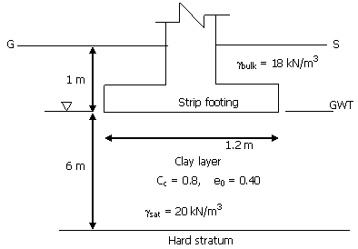

79. If the pressure acting on the footing is 40 kPa, the consolidation settlement of the footing will be
(a) 0.89 mm (b) 8.9 mm (c) 89.0 mm (d) None of these

80. If the elastic modulus and the Poisson’s ratio of the clay layer are respectively 50×10³kPa and 0.4 and if the influence factor for the strip footing is 1.75, the elastic settlement of the footing will be
(a) 0.41 mm (b) 1.41 mm (c) 14.1 mm (d) None of these

Data for Q. 81-82 are given below. Solve the problems and choose correct answers.
A very wide rectangular channel carries a discharge of 8m³/s per m width. The channel has a bed slope of 0.004 and Manning’s roughness coefficient, n = 0.015. At a certain section of the channel, the flow depth is 1m.

81. What Gradually Varied Flow profile exists at this section?
(a) M₂ (b) M₃ (c) S₂ (d) S₃

82. At what distance from this section the flow depth will be 0.9 m? (Use the direct step method employing a single step)
(a) 65 m downstream (b) 50 m downstream
(c) 50 m downstream (d) 65 m downstream

Data for Q.83-84 are given below. Solve the problems and choose correct answers.
A pipeline (diameter 0.3 m, length 3 km) carries water from point P to point R (see figure). The piezometric heads at P and R are to be maintained at 100 m and 80 m, respectively. To increase the discharge, a second pipe is added in parallel to the existing pipe from Q to R. The length of the additional pipe is also 2 km. Assume the friction factor, f = 0.04 for all pipes and ignore minor losses.
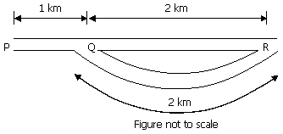

83. What is the increase in discharge if the additional pipe has same diameter (0.3 m)?
(a) 0% (b) 33% (c) 41% (d) 67%

84. If there is no restriction on the diameter of the additional pipe, what would be the maximum increase in discharge theoretically possible from this arrangement?
(a) 0% (b) 50% (c) 67% (d) 73%

Data for Q.85-86 are given below. Solve the problems and choose correct answers.
An average rainfall of 16 cm occurs over a catchment during a period of 12 hours with uniform intensity. The unit hydrograph (unit depth = 1 cm, duration = 6 hours) of the catchment rises linearly from 0 to 30 cumecs in six hours and then falls linearly from 30 to 0 cumecs in the next 12 hours. φ index of the catchment is known to be 0.5 cm/hr. Base flow in the river is known to be 5 cumecs.

85. Peak discharge of the resulting direct runoff hydrograph shall be
(a) 150 cumecs (b) 225 cumecs (c) 230 cumecs (d) 360 cumecs

86. Area of the catchment in hectares is
(a) 97.20 (b) 270 (c) 9720 (d) 2700

Data for Q.87-88 are given below. Solve the problems and choose correct answers.
A conventional Activated Sludge Plant treating 1000 m³/d of municipal waste water disposes of its anaerobically digested sludge on relatively impervious farmland. Use the following data
1. Raw Sewage : SS = 225 mg/I (70% volatile)
BOD = 190 mg/I (Excess activated
sludge returned to primary)
2. Primary Setting : SS-50% removal BOD-30% removal
3. Excess Activated Sludge 0.4 g VSS produced per g BOD
applied (80% Volatile of total)
4. Anaerobic Digester : VSS reduced 50% Digested Sludge
Concentration – 60% Sludge Specific
Gravity-1
5. Application on farmland : 2 m³/ha.d

87. Total volatile suspended solids to be anaerobically digested (kg/d, VSS) shall be
(a) 133 (b) 168 (c) 233 (d) 245

88. Area requirements (ha) for disposal of the sludge on farmland shall be
(a) 2.95 (b) 1.95 (c) 0.95 (d) 0.55

Data for Q.89-90 are given below. Solve the problems and choose correct answers.
A water treatment plant treating 10 mld of water requires 20mg/I of filter Alum, Al₂ (SO₄)₃. 18 H₂O. The water has 6 mg/1 of alkalinity as CaCo₃ (Al = 26.97, S=32, O=16, H=1, Ca=40, and C=12).

89. Total alkalinity requirement (10⁶ mg per day as CaCO₃) matching filter Alum, shall be
(a) 180 (b) 120 (c) 90 (d) 60

90. Quantity of Quick Lime required (10⁶ mg per year as CaO) shall be
(a) 2132 (b) 3000 (c) 4132 (d) 6132

Answer Key Civil Engineering GATE 2003
1 | c | 2 | d | 3 | a | 4 | c | 5 | a | 6 | b | 7 | d | 8 | c | 9 | b | 10 | a
11 | a | 12 | b | 13 | c | 14 | b | 15 | a | 16 | b | 17 | d | 18 | c | 19 | b | 20 | b
21 | c | 22 | b | 23 | d | 24 | c | 25 | d | 26 | c | 27 | d | 28 | c | 29 | a | 30 | c
31 | b | 32 | b | 33 | a | 34 | b | 35 | b | 36 | a | 37 | d | 38 | a | 39 | a | 40 | c
41 | c | 42 | a | 43 | a | 44 | d | 45 | b | 46 | c | 47 | c | 48 | b | 49 | a | 50 | a
51 | d | 52 | b | 53 | d | 54 | b | 55 | d | 56 | a | 57 | a | 58 | d | 59 | b | 60 | a
61 | c | 62 | c | 63 | d | 64 | d | 65 | b | 66 | b | 67 | c | 68 | a | 69 | b | 70 | c
71 | a | 72 | c | 73 | c | 74 | d | 75 | a | 76 | c | 77 | b | 78 | d | 79 | c | 80 | a
81 | d | 82 | b | 83 | c | 84 | c | 85 | b | 86 | c | 87 | a | 88 | d | 89 | c | 90 | d
End of Question Paper

