GATE 2009 Civil Engineering Question Paper
Q. No. 1 – 20 Carry One Mark Each

1. A square matrix B is skew symmetric if
(A) B^{T} = - B (B) B^{T} = B (C) B⁻¹ = B (D) B⁻¹ = B^{T}

2. For a scalar function f(x, y, z) = x² + 3x², the gradient at the point P (1, 2, -1) is
(A) (B) (C) (D)

3. The analytic function f(z) = 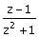 has singularities at
(A) 1 and -1 (B) 1 and i (C) 1 and -i (D) i and -i

4. A thin walled cylindrical pressure vessel having a radius of 0.5m and wall thickness of 25mm is subjected to an internal pressure of 700kPa. The hoop stress developed is
(A) 14MPa (B) 1.4MPa (C) 0.14MPa (D) 0.014MPa

5. The modulus of rupture of concrete in terms of its characteristic cube compressive strength (f_{ck}) in MPa according to IS 456:2000 is
(A) 5000f_{ck} (B) 0.7f_{ck} (C) 5000 (D) 0.7

6. In the theory of plastic bending of beams, the ratio of plastic moment to yield moment is called
(A) Shape factor (B) Plastic section modulus
(C) Modulus of resilience (D) Rigidity modulus

7. For limit state of collapse, the partial safety factors recommended by IS 456:2000 for estimating the design strength of concrete and reinforcing steel are respectively
(A) 1.15 and 1.5 (B) 1.0 and 1.0 (C) 1.5 and 1.15 (D) 1.5 and 1.0

8. The point within the cross sectional plane of a beam through which the resultant of the external loading on the beam has to pass through to ensure pure bending without twisting of the cross-section of the beam is called
(A) Moment centre (B) Centroid
(C) Shear centre (D) Elastic centre

9. The square root of the ratio of moment of inertia of the cross section to its cross sectional area is called
(A) Second moment of area (B) Slenderness ratio
(C) Section modulus (D) Radius of gyration

10. Deposit with flocculated structure is formed when
(A) Clay particles settle on sea bed
(B) Clay particles settle on fresh water lake bed
(C) Sand particles settle on river bed
(D) Sand particles settle on sea bed

11. Dilatancy correction is required when a strata is
(A) Cohesive and saturated and also has N Value of SPT > 15
(B) Saturated silt/fine sand and N value of SPT < 10 after the overburden correction
(C) Saturated silt/fine sand and N value of SPT >15 after the overburden correction
(D) Coarse sand under dry condition and N value of SPT < 10 after the overburden correction

12. A precast concrete pile is driven with a 50kN hammer falling through a height of 1.0m with an efficiency of 0.6. The set value observed is 4mm per blow and the combined temporary compression of the pile, cushion and the ground is 6mm. As per Modified Hiley Formula, the ultimate resistance of the pile is
(A) 3000kN (B) 4285.7kN (C) 8.333kN (D) 11905kN

13. Direct step method of computation for gradually varied flow is
(A) Applicable to non-prismatic channels
(B) Applicable to prismatic channels
(C) Applicable to both prismatic and non-prismatic channels
(D) Not applicable to both prismatic and non-prismatic channels

14. The relationship among specific yield (Sy), specific retention (Sr) and porosity (h) of an aquifer is
(A) S_{y} = S_{r} + h (B) S_{y} = S_{r} − h
(C) S_{y} = h − S_{r} (D) S_{y} = S_{r} + 2h

15. The depth of flow in an alluvial channel is 1.5m. If critical velocity ratio is 1.1 and Manning’s n is 0.018, the critical velocity of the channel as per Kennedy’s method is
(A) 0.713m/s (B) 0.784m/s (C) 0.879m/s (D) 1.108m/s

16. The reference pressure used I the determination of sound pressure level is
(A) 20μPa (B) 20db (C) 10μPa (D) 10db

17. Particulate matter (fly ash) carried in effluent gases from the furnaces burning fossil fuels are better removed by
(A) Cotton bag house filter (B) Electrostatic precipitator (ESP)
(C) Cyclone (D) Wet scrubber

18. The value of lateral friction or side friction used in the design of horizontal curve as per India Roads Congress guidelines is
(A) 0.40 (B) 0.35 (C) 0.24 (D) 0.15

19. During a CBR test, the load sustained by a remolded soil specimen at 5.0mm penetration is 50kg. The CBR value of the soil will be
(A) 10.0% (B) 5.0% (C) 3.6% (D) 2.4%

20. In quadrantal bearing system, bearing of a line varies from
(A) 0º to 360º (B) 0º to 180º (C) 0º to 90º (D) 0º N to 90ºs

Q. No. 21 – 56 Carry Two Marks Each

21. For a scalar function f (x, y, z) = x² + 3y² + 2z², the directional derivative at the point P(1, 2, -1) in the direction of a vector is
(A) −18 (B) −3 (C) 3 (D) 18

22. The value of the integral 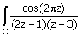 dx (where C is a closed curve given by |z| = 1) is
(A) -pi (B) (C) (D) pi

23. Solution of the differential equation 3y + 2x = - represents a family of
(A) ellipses (B) circles (C) parabolas (D) hyperbolas

24. Laplace transform for the function f (x) = cosh(ax) is
(A) 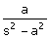 (B) 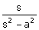 (C) 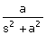 (D) 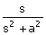

25. In the solution of the following set of linear equations by Gauss elimination using partial pivoting 5x + y + 2z = 34; 4y − 3z = 12; and 10x − 2y + z = −4.
The pivots for elimination of x and y are
(A) 10 and 4 (B) 10 and 2 (C) 5 and 4 (D) 5 and -4

26. The standard normal probability function can be approximated as
F(x_{N}) = 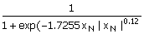
Where xN = standard normal deviate. If mean and standard deviation of annual precipitation are 102cm and 27cm respectively, the probability that the annual precipitation will be between 90cm and 102cm is
(A) 66.7% (B) 50.0% (C) 33.3% (D) 16.7%

27. Consider the following statements:
I. On a principal plane, only normal stress acts
II. On a principal plane, both normal and shear stresses act
III. On a principal plane, only shear stress acts
IV. Isotropic state of stress is independent of frame of reference
The TRUE statements are
(A) I and IV (B) II (C) II and IV (D) II and III

28. The degree of static indeterminacy of a rigidly jointed frame in a horizontal plane and subjected to vertical loads only, as shown in figure below is
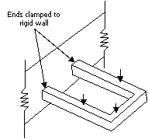
(A) 6
(B) 4
(C) 3
(D) 1

29. A 12mm thick plate is connected to two 8mm plates, on either side through a 16mm diameter power driven field rivet as shown in the figure below. Assuming permissible shear stress as 90MPa and permissible bearing stress as 270MPa in the rivet, the rivet value of the joint is
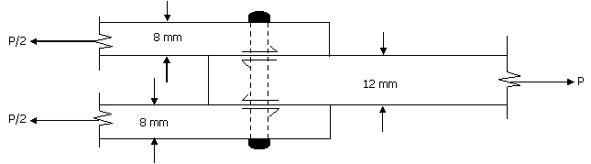
(A) 56.70kN (B) 43.29kN (C) 36.19kN (D) 21.65kN

30. A hollow circular shaft has an outer diameter of 100mm and a wall thickness of 25mm. The allowable shear stress in the shaft is 125MPa. The maximum torque the shaft can transmit is
(A) 46kN m (B) 24.5kN m (C) 23kN m (D) 11.5kN m

31. Consider the following statements for a compression member:
I. The elastic critical stress in compression increases with decrease in slenderness ratio
II. The effective length depends on the boundary conditions at its ends
III. The elastic critical stress in compression is independent of the slenderness ratio
IV. The ratio of the effective length to its radius of gyration is called as slenderness ratio

The TRUE statements are
(A) II and III (B) III and IV (C) II, III and IV (D) I, II and IV

32. Group I gives the shear force diagrams and Group II gives the diagrams of beams with supports and loading. Match the Group I with Group II

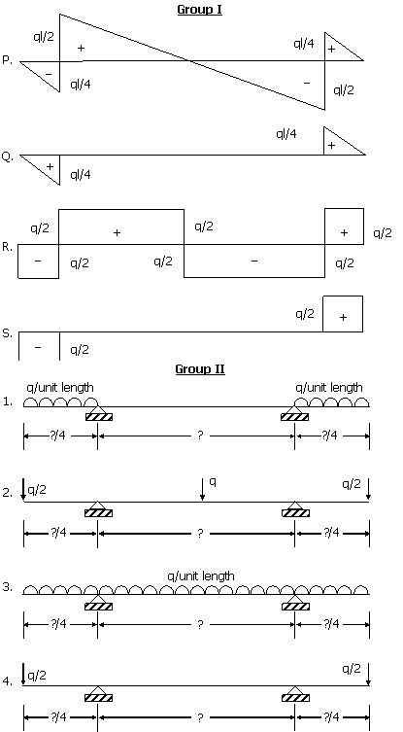
(A) P-3,Q-1,R-2,S-4 (B) P-3,Q-4,R-2,S-1
(C) P-2,Q-1,R-4,S-3 (D) P-2,Q-4,R-3,S-4

33. A rectangular concrete beam of width 120mm and depth 200mm is prestressed by pretensioning to a force of 150kN at an eccentricity of 20mm. The cross sectional area of the prestressing steel is 187.5mm². Take modulus of elasticity of steel and concrete as 2.1 × 10⁵ MPa and 3.0×10⁴ MPa respectively. The percentage loss of stress in the prestressing steel due to elastic deformation of concrete is
(A) 8.75 (B) 6.125 (C) 4.81 (D) 2.19

34. Column I gives a list of test methods for evaluating properties of concrete and Column II gives the list of properties
Column I Column II
P. Resonant frequency test 1. Tensile strength
Q. Rebound hammer test 2. Dynamic modulus of elasticity
R. Split cylinder test 3. Workability
S. Compacting factor test 4. Compressive strength
The correct match of the test with the property is
(A) P-2,Q-4,R-1,S-3 (B) P-2,Q-1,R-4,S-3
(C) P-2,Q-4,R-3,S-1 (D) P-4,Q-3,R-1,S-2

35. The laboratory test results of a soil sample are given below:
Percentage finer than 4.75 mm = 60
Percentage finer than 0.075 mm = 30
Liquid Limit = 35%
Plastic Limit = 27%
The soil classification is
(A) GM (B) SM (C) GC (D) ML-MI

36. A plate load test is carried out on a 300mm× 300mm plate placed at 2 m below the ground level to determine the bearing capacity of a 2m× 2m footing placed at same depth of 2m on a homogeneous sand deposit extending 10m below ground. The ground water table is 3m below the ground level. Which of the following factors does not require a correction to the bearing capacity determined based on the load test?
(A) Absence of the overburden pressure during the test
(B) Size of the plate is much smaller than the footing size
(C) Influence of the ground water table
(D) Settlement is recorded only over a limited period of one or two days

37. Water flows through a 100mm diameter pipe with a velocity of 0.015m/sec. If the kinematic viscosity of water is 1.13 ´ 10⁻⁶m² / sec, the friction factor of the pipe material is
(A) 0.0015 (B) 0.032 (C) 0.037 (D) 0.048

38. A rectangular open channel of width 4.5m is carrying a discharge of 100m3/sec.
The critical depth of the channel is
(A) 7.09m (B) 3.69m (C) 2.16m (D) 1.31m

39. Water (g_{w} = 9.879kN/m³) flows with a flow rate of 0.3m³/sec through a pipe AB of 10m length and of uniform cross section. The end ‘B’ is above end ‘A’ and the pipe makes an angle of 30º to the horizontal. For a pressure of 12kN/m² at the end ‘B’, the corresponding pressure at the end ‘A’ is
(A) 12.0kN/m2 (B) 17.0kN/m2 (C) 56.4kN/m2 (D) 61.4kN/m2

40. An agricultural land of 437ha is to be irrigated for a particular crop. The base period of the crop is 90 days and the total depth of water required by the crop is 105cm. If a rainfall of 15cm occurs during the base period, the duty of irrigation water is
(A) 437ha/cumec (B) 486ha/cumec
(C) 741ha/cumec (D) 864ha/cumec

41. Column I Column II
P. Coriolis effect 1. Rotation of earth
Q. Fumigation 2. Lapse rate and vertical temperature profile
R. Ozone layer 3. Inversion
S. Maximum mixing depth 4. Dobson
(mixing height)
The correct match of Column I with Column II is
(A) P-2,Q-1,R-4,S-3 (B) P-2,Q-1,R-3,S-4
(C) P-1,Q-3,R-2,S-4 (D) P-1,Q-3,R-4,S-2

42. A horizontal flow primary clarifier treats wastewater in which 10%, 60% and 30% of particles have settling velocities of 0.1mm/s, 0.2mm/s, 0.2mm/s, and 1.0mm/s respectively. What would be the total percentage of particles removed if clarifier operates at a Surface Overflow Rate (SOR) of 43.2m³/m².d?
(A) 43% (B) 56% (C) 86% (D) 100%

43. An aerobic reactor receives wastewater at a flow rate of 500m³/d having a COD of 2000mg/L. The effluent COD is 400mg/L. Assuming that wastewater contains 80% biodegradable waste, the daily volume of methane produced by the reactor is
(A) 0.224m³ (B) 0.280m³ (C) 224m³ (D) 280m³

44. Column I Column II
P. Grit chamber 1. Zone settling
Q. Secondary settling tank 2. Stoke’s law
R. Activated sludge process 3. Aerobic
S. Trickling filter 4. Contact stabilisation
The correct match of Column I with Column II is
(A) P-1,Q-2,R-3,S-4 (B) P-2,Q-1,R-3,S-4
(C) P-1,Q-2,R-4,S-3 (D) P-2,Q-1,R-4,S-3

45. Which of the following stress combinations are appropriate in identifying the critical condition for the design of concrete pavements?
Type of Stress Location
P. Load 1. Corner
Q. Temperature 2. Edge
3. Interior
(A) P-2, Q-3 (B) P-1, Q-3 (C) P-3, Q-1 (D) P-2, Q-2

46. A rest vertical curve joins two gradients of +3% and -2% for a design speed of 80km/h and the corresponding stopping sight distance of 120m. The height of driver’s eye and the object above the road surface are 1.20m and 0.15m respectively. The curve length (which is less than stopping sight distance) to be provided is
(A) 120m (B) 152m (C) 163m (D) 240m

47. On a specific highway, the speed-density relationship follows the Greenberg’s model
[v = v_{f} ln (k_{j} / k)] , where v_{f} and k_{f} are the free flow speed and jam density respectively. When the highway is operating at capacity, the density obtained as per this model is
(A) e.k_{j} (B) k_{j} (C) k_{j} / 2 (D) k_{j} / e

48. A three-phase traffic signal at an intersection is designed for flows shown in the figure below. There are six groups of flows identified by the numbers 1 through 6. Among these 1, 3, 4 and 6 are through flows and, 2 and 5 are right turning.
Which phasing scheme is not feasible?
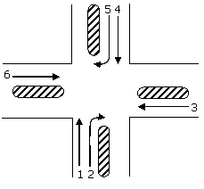

Combination choice | Phase I | Phase II | Phase III
P | 1, 4 | 2, 5 | 3, 6
Q | 1, 2 | 4, 5 | 3, 6
R | 2, 5 | 1, 3 | 4, 6
S | 1, 4 | 2, 6 | 3, 5

(A) P (B) Q (C) R (D) S

49. The magnetic bearing of a line AB was N 59º 30¢ W in the year 1967, when the declination was 4º 10¢ E. If the present declination is 3ºW, the whole circle bearing of the line is
(A) 299º 20¢ (B) 307º 40¢ (C) 293º 20¢ (D) 301º 40¢

50. Determine the correctness or otherwise of the following Assertion [a] and the Reason [r] :
Assertion [a] : Curvature correction must be applied when the sights are long
Reason [r] : Line of collimation is not a level line but is tangential to the level line
(A) Both [a] and [r] are true and [r] is the correct reason for [a]
(B) Both [a] and [r] are true but [r] is not the correct reason for [a]
(C) Both [a] and [r] are false
(D) [a] is false but [r] is true

Common Data Questions: 51 & 52

Examine the test arrangement and the soil properties given below

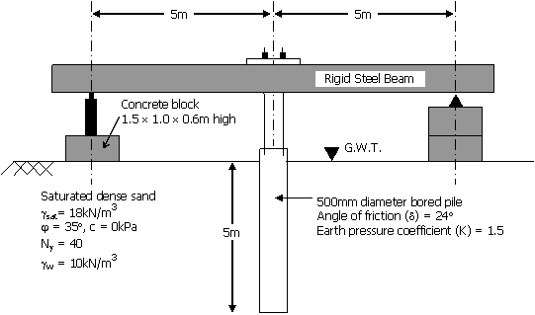
51. The maximum pressure that can be applied with a factor of safety of 3 through the concrete block, ensuring no bearing capacity failure in soil using Terzaghi’s bearing capacity equation without considering the shape factor, depth factor and inclination factor is
(A) 26.67kPa (B) 60kPa (C) 90kPa (D) 120kPa

52. The maximum resistance offered by the soil through skin friction while pulling out the pile from the ground is
(A) 104.9kN (B) 209.8kN (C) 236kN (D) 472kN

Common Data Questions: 53 & 54
Following chemical species were reported for water sample from a well:
Specials | Concentration (milli equivalent/L)
Chloride (Cl⁻) | 15
Sulphate (SO₄²⁻) | 15
Carbonate (CO₃²⁻) | 05
Bicarbonate (HCO₃⁻) | 30
Calcium (Ca²⁺) | 12
Magnesium (Mg²⁺) | 18
pH | 8.5

53. Total hardness in mg/L as CaCO₃ is
(A) 1500 (B) 2000 (C) 3000 (D) 5000

54. Alkalinity present in the water in mg/L as CaCO₃ is
(A) 250 (B) 1500 (C) 1750 (D) 5000

Common Data Questions: 55 & 56
One hour triangular unit hydrograph of a watershed has the peak discharge of 60m³/sec.cm at 10hours and time base of 30 hours. The findex is 0.4cm per hour and base flow is 15m³m/sec
55. The catchment area of the watershed is
(A) 3.24km² (B) 32.4km² (C) 324km² (D) 3240km²
56. If these is rainfall of 5.4cm in 1 hour, the ordinate of the flood hydrograph at 15th hour is
(A) 225 m³/sec (B) 240 m³/sec (C) 249 m³/sec (D) 258 m³/sec
Linked Answer Questions: Q.57 to Q.60 Carry Two Marks Each
Statement for Linked Answer Questions: 57 & 58
In the cantilever beam PQR shown in figure below, the segment PQ has flexural rigidity EI and the segment QR has infinite flexural rigidity.

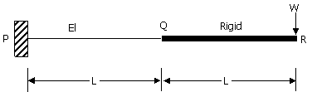

57. The deflection and slope of the beam at 'Q' are respectively
(A) 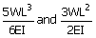 (B) 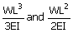
(C) 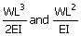 (D) 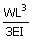and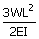
58. The deflection of the beam at 'R' is
(A) 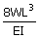 (B) 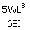 (C) 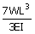 (D) 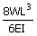
Statement for Linked Answer Questions: 59 & 60
59. A saturated undisturbed sample from a clay strata has moisture content of 22.22% and specific weight of 2.7. Assuming g_{w} = 10kN/m³, the void ratio and the saturated unit weight of the clay, respectively are
(A) 0.6 and 16.875kN/m³ (B) 0.3 and 20.625kN/m³
(C) 0.6 and 20.625kN/m³ (D) 0.3 and 16.975kN/m³
60. Using the properties of the clay layer derived from the above question, the consolidation settlement of the same clay layer under a square footing (neglecting its self weight) with additional data shown in the figure below (assume the stress distribution as 1H:2V from the edge of the footing and
g_{w} = 10kN/m³) is

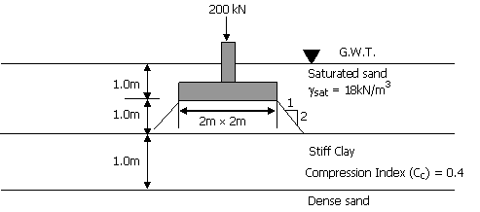
(A) 32.78mm (B) 61.75mm (C) 79.5mm (D) 131.13mm

