GATE Question Papers Mechanical Engineering 2005 (ME)

Q.1 to Q.30 Carry One Mark Each.

1. Strokes theorem connects
(a) a line integral and a surface integral
(b) a surface integral and a volume integral
(c) a line integral and a volume integral
(d) Gradient of a function and its surface integral

2. A lot has 10% defective items. Ten items are chosen randomly from this lot. The probability that exactly 2 of the chosen items are defective is
(a) 0.0036 (b) 0.1937 (c) 0.2234 (d) 0.3874

3. 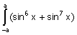 dx is equal to
(a) 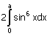 (b) 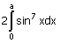
(c) 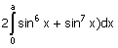 (d) zero

4. A is a 3 × 4 real matrix and A x = b is an inconsistent system of equations. The highest possible rank of A is
(a) 1 (b) 2 (c) 3 (d) 4

5. Changing the order of the integration in the double integral
I = f(x, y) dydx leads to I = f(x, y) dydx. What is q?
(a) 4y (b) 16y² (c) x (d) 8

6. The time variation of the position of a particle in rectilinear motion is given by x − 2t³ + t² + 2t . If v is the velocity and a the acceleration of the particle in consistent units, the motion started with
(a) v=0, a=0 (b) v=0, a=2
(c) v=2 a=0 (d) v =2 a=2

7. A simple pendulum of length 5m, with a bob of mass 1 kg, is in simple harmonic motion. As it passes through its mean position, the bob has a speed of 5 m/s. the net force on the bob at the mean position is
(a) zero (b) 2.5 N (c) 5 N (d) 25

8. A uniform, slender cylindrical rod is made of a homogeneous and isotropic material. The rod rests on a frictionless surface. The rod is heated uniformly. If the radial and longitudinal thermal stresses are represented by σ_{r} and σ_{z}, respectively, then
(a) σ_{r} = 0, σ_{z} = 0 (b) σ_{r} ≠ 0, σ_{z} = 0
(c) σ_{r} = 0, σ_{z} ≠ 0 (d) σ_{r} ≠ 0, σ_{z} ≠ 0

9. Two identical cantilever beams are supported as shown, with their free ends in contact through a rigid roller. After the load P is applied, the free ends will have
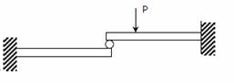
(a) equal deflections but not equal slopes
(b) equal slopes but not equal deflections
(c) equal slopes as well as equal deflections
(d) neither equal slopes nor equal deflections

10. The number of degrees of freedom of a planar linkage with 8 links and 9 simple revolute joints is
(a) 1 (b) 2 (c) 3 (d) 4

11. There are four samples P, Q, R and S, with natural frequencies 64, 96, 128 and 256 Hz respectively. There are mounted on test setups for conducting vibration experiments. If a loud pure not of frequency 144 Hz is produced by some instrument, which of the samples will show the most perceptible induced vibration?
(a) P (b) Q (c) R (d) S

12. Which one of the following is a criterion in the design of hydrodynamic journal bearings?
(a) Sommerfeld number (b) Rating life
(c) Specific dynamic capacity (d) Rotation factor

13. The velocity components in the x and y directions of a two dimensional potential flow are u and v, respectively, then is equal to
(a) (b) 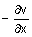
(c) (d) 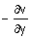

14. In a case of one dimensional heat conduction in a medium with constant properties, T is the temperature at position x, at time t. then is proportional to
(a) (b)
(c) 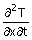 (d)

15. The following four figures have been drawn to represent a fictitious thermodynamics cycle, on the p-v and T-s planes.

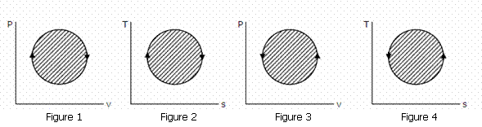

According to the first law of thermodynamics, equal areas are enclosed by

(a) Figures 1 and 2 (b) Figures 1 and 3
(c) Figures 1 and 4 (d) Figures 2 and 3

16. A p-v diagram has been obtained from a test on a reciprocating compressor. Which of the following represents that diagram?

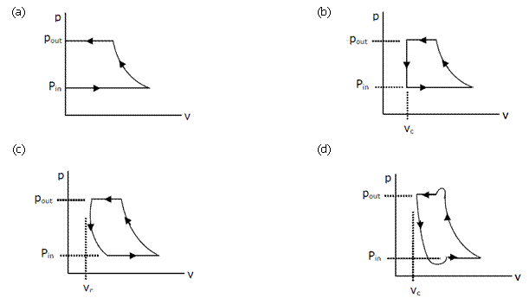

17. The following figure was generated from experimental data relating Spectral black body emissive power to wave length at threeTemperatures
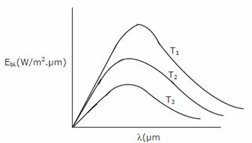
T₁ T₂ |and T₃ (T₁ > T₂ < T₃).

The conclusion is that the measurements are
(a) correct because the maxima in E_{bλ} show that correct trend
(b) correct because Planck‘s law is satisfied
(c) wrong because the Stefan Boltzmann law is not satisfied
(d) wrong because Wien‘s displacement law is not satisfied

18. For a typical sample of ambient air (at 35°C, 75% relative humidity and standard atmospheric pressure), the amount of moisture in kg per kg of dry air will be approximately
(a) 0.002 (b) 0.027 (c) 0.25 ` (d) 0.75

19. Water at 42° is sprayed into a stream of air at atmospheric pressure; dry bulb temperature of 40°C and a wet bulb temperature of 20°C. The air leaving the spray humidifier is not saturated. Which of the following statements is true?
(a) Air gets cooled and humidified (b) Air gets heated and humidified
(c) Air gets heated and dehumidified (d) Air gets cooled and dehumidified

20. Match the items of List I (Equipment) with the items of List II (Process) and select the correct answer using the given codes.
List I (Equipm ent) List (Process)
P - Hot Chamber Machine 1 - Cleaning
Q - Muller 2 - Core making
R - Dielectric Baker 3 - Die casting
S - Sand Blaster 4 - Annealing
5 - Sand mixing
(a) P − 2 Q − 1 R − 4 S − 5 (b) P − 4 Q − 2 R − 3 S − 5
(c) P − 4 Q − 5 R − 1 S − 2 (d) P − 3 Q − 5 R − 2 S − 1

21. When the temperature of a solid metal increases.
(a) strength of the metal decreases but ductility increases
(b) both strength and ductility of the metal decrease
(c) both strength and ductility of the metal increase
(d) strength of the metal increases but ductility decreases

22. The strength of a brazed joint
(a) decreases with increase in gap between the two joining surfaces
(b) increases with increase in gap between the two joining surfaces
(c) decreases up to certain gap between the two joining surfaces beyond which it increases
(d) increases up to certain gap between the two joining surfaces beyond which it decreases

23. A zigzag cavity in a block of high strength alloy is to be finish machined. This can be carried out by using
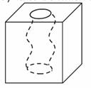
(a) electric discharge machining
(b) electro-chemical machining
(c) laser beam machining
(d) abrasive flow machining

24. In order to have interference fit, it is essential that the lower limit of the shaft should be
(a) greater than the upper limit of the hole (b) lesser than the upper limit of the hole
(c) greater than the lower limit of the hole (d) lesser than the lower limit of the hole

25. When 3-2-1 principle in used to support and locate a three dimensional work-piece during machining, the number of degrees of freedom that are restricted is
(a) 7 (b) 8 (c) 9 (d) 10

26. The figure below shows a graph, which qualitatively relates cutting speed and cost per piece produced.
The three curves, 1, 2 and 3 respectively represent
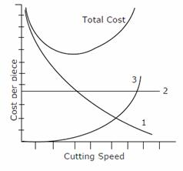
(a) machining cost, non-productive cost, tool changing cost
(b) non-productive cost, machining cost, tool changing cost
(c) tool changing cost, machining cost, non-productive cost
(d) tool changing cost, non-productive cost, machining cost
27. Which among the NC operations given below are continuous path operations?
Arc Welding (AW) Milling (M)
Drilling (D) Punching in Sheet Metal (P)
Laser Cutting of Sheet Metal (LC) Spot Welding (SW)

(a) AW, LC and M (b) AW, D, LC and M
(c) D, LC, P and SW (d) D, LC and SW

28. An assembly activity is represented on an Operation Process Chart by the symbol
(a)  (b) A (c) D (d) O

29. The sales of a product during the last four years were 860, 880, 870 and 890 units.The forecast for the fourth year was 876 units.If the forecast for the fifth year, using simple exponential smoothing, is equal to the forecast using a three period moving average, the value of the exponential smoothing constant α is
(a) (b) (c) (d)

30. Consider a single server queuing model with Poisson arrivals( λ = 4 / hour) and exponential service
( μ = 4 / hour) .The number in the system is restricted to amaximum of 10.the probability that
a person who comes in leaves without joining the queue is

(a) (b) (c) (d)

Q.31 to Q.80 Carry One Marks Each.

31. Which one of the following is an eigen vector of the matrix

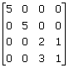?

(a) 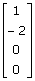 (b) (c) 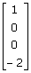 (d) 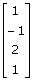

32. With a 1 unit change in b, what is the change in x in the solution of the system of equations
x + y = 2,1.01x + 0.99y = b ?

(a) zero (b) 2 units (c) 50 units (d) 100 units

33. By a change of variables x(u,v)=uv, y(u,v)= in a double integral, the ntegrand f (x, y) changes to f 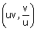 φ (u,v).Then, φ(u,v) is
(a) 2 (b) 2uv (c) v² (d) 1

34. The right circular cone of largest volume that can be enclosed by a sphere of 1 m adius has a height of
(c) 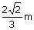 (d)
(a) (b)

35. If x² 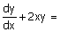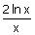, and y(1) = 0, that what is y (e)?
(a) e (b)1 (c) (d)
36. The line integral of the vector function origin to the point P(1,1,1)
(a) is 1 (b) is zero
(c) is −1 (d) cannot be determined without specifying the path

37. Starting from x₀ =1, one step of Newton-Raphson method in solving the equation x³ +3 x - 7 = 0 gives the next value (x₁ ) as
(a) x₁ = 0.5 (b) x₁ =1.406
(c) x₁ =1.5 (d) x₂ = 2

38. A single die is thrown twice. What is the probability that the sum is neither 8 or 9?

(a) (b)

(c) (d)

39. Two books of mass 1 kg each are kept on a table, one over the other. The coefficient of friction on every pair of contacting surfaces is 0.3. The lower book is pulled with a horizontal force FTSE minimum value of F for which slip occurs between the two books is
(a) zero (b) 1.06 N
(c) 5.74 N (d) 8.83 N

40. A shell is fired from a cannon. At the instant the shell is just about to leave the barrel, its velocity relative to the barrel is 3m/s, while the barrel is swinging upwards with a constant angular velocity of 2 rad/sec.The magnitude of the absolute velocity of the shell is
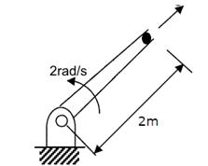

(a) 3 m/s (b) 4 m/s 2rad/s
(c) 5 m/s 2m (d) 7 m/s

41. An elevator (lift) consists of the elevator cage and a counter weight, of mass m each. The cage and the counterweight are connected by a chain that passes over a pulley. The pulley is coupled to a motor. It is desired that the elevator should have a maximum stopping time of t seconds from a peak speed v. if the inertia of the pulley and the chain are neglected, the minimum power that the motor must have is

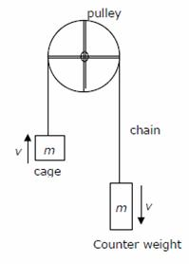

(a) mv² (b) 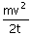 (c) 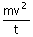 (d) 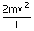

42. A 1 kg mass of clay, moving with a velocity of 10 m/s, strikes a stationary wheel and sticks to it. The solid wheel has a mass of 20 kg and a radius of 1 m. assuming that the wheel and the ground are both rigid and that the wheel is set into pure rolling motion, the angular velocity of the wheel immediately after the impact is approximately

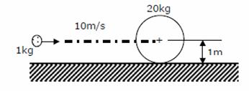

(a) zero (b) rad /s (c) 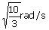 (d) 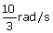

43. The two shafts AB and BC, of equal length and diameters d and 2d, are made of the same material. They are joined at B through a shaft coupling, while the ends and C are built-in (cantilevered).A twisting moment T is applied to the coupling. If T_{A} and T_{C}represent the twisting moments at the ends A and C respectively, then
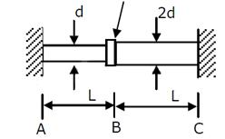

(a) T_{C} = T_{A}
(b) T_{C} = 8T_{A}
(c) T_{C} = 16T_{A}
(d) T_{A} = 16T_{C}

44. A beam is made up of two identical bars AB and BC, by hinging them together at B. The end A is built-in (cantilevered) and the end C is simply supported. With the load P acting as shown, the bending moment at A is
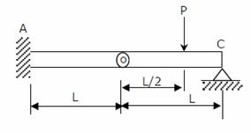

(a) zero (b) (c) (d) indeterminate

45. A cantilever beam carries the anti-symmetric load shown, where w₀ is the peak intensity of the distributed load. Qualitatively, the correct bending moment diagram for this beam is

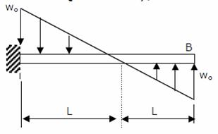

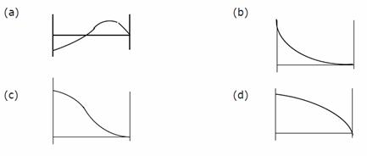
46. A cantilever beam has the square cross section of 10 mm × 10 mm. It carries a transverse load of 10 N. considering only the bottom fibres of the beam, the correct representation of the longitudinal variation of the bending stress is

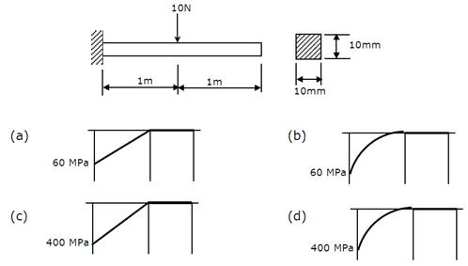

47. In a cam-follower mechanism, the follower needs to rise through 20 mm during 60° of cam rotation, the first 30° with a constant acceleration and then with a deceleration of the same magnitude. The initial and final speeds of the follower are zero. The cam rotates at a uniform speed of 300 rpm. The maximum speed of the follower is
(a) 0.60 m/s (b) 1.20 m/s (c) 1.68 m/s (d) 2.40 m/s

48. A rotating disc of 1 m diameter has two eccentric masses of 0.5 kg each at radii of 50 mm and 60 mm at angular positions of 0° and 150°, respectively. A balancing mass of 0.1 kg is to be used to balance the rotor. What is the radial position of the balancing mass?
(a) 50 mm (b) 120 mm (c) 150 mm (d) 280 mm

49. In a spring-mass system, the mass is 0.1 kg and the stiffness of the spring is 1 kN/m. By introducing a damper, the frequency of oscillation is found to be 90% of the original value. What is the damping coefficient of the damper?
(a) 1.2 N.s/m (b) 3.4 N.s/m (c) 8.7 N.s/m (d) 12.0 N.s/m

50. The Mohr‘s circle of plane stress for a point in a body is shown. The design is to be done on the basis of the maximum shear stress theory for yielding. Then, yielding will just begin if the designer chooses a ductile material whose yield strength is
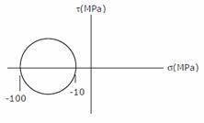
(a) 45 MPa (b) 50 MPa (c) 90 MPa (d) 100 MPa

51. A weighing machine consists of a 2 kg pan resting on a spring. In this condition, the pan resting on the spring, the length of the spring is 200 mm. When a mass of 20 kg is placed on the pan, the length of the spring becomes 100 mm. For the spring, the un-deformed length l₀ and the spring constant k (stiffness) are
(a) l₀ = 220 mm, k =1862 N / m (b) l₀ = 210mm, k = 1960N / m
(c) l₀ = 200 mm, k =1960 − N / m (d) l₀ = 200 mm, k = 2156 N / m

52. A venturimeter of 20 mm throat diameter is used to measure the velocity of water in a horizontal pipe of 40 mm diameter. If the pressure difference between the pipe and throat sections is found to be 30 kPa then, neglecting frictional losses, the flow velocity is
(a) 0.2 m/s (b) 1.0 m/s (c) 1.4 m/s (d) 2.0 m/s

53. A U-tube manometer with a small quantity of mercury is used to measure the static pressure difference between two locations A and B in a conical section through which an incompressible fluid flows. At a particular flow rate, the mercury col umn appears as shown in the figure. The density of mercury is 13600 kg/m³ and g = 9.81 m/s² . Which of the following is correct?
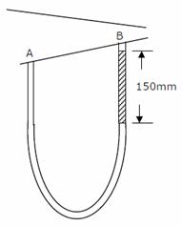
(a) Flow direction is A to B and p_{A} − p_{B} = 20 kPa
(b) Flow direction is B to A and p_{A} − p_{B} = 1.4 kPa
(c) Flow direction is A to B and p_{B} − p_{A} = 20 kPa
(d) Flow direction is B to A and p_{B} − p_{A} = 1.4 kPa

54. A reversible thermodynamic cycle containing only three processes and producing work is to be constructed. The constraints are: (i) there must be one isothermal process, (ii) there must be one isentropic process, (iii) the maximum and minimum cycle pressures and the clearance volume are fixed, and (iv) polytropic processes are not allowed. Then the numbers of possible cycles are
(a) 1 (b) 2 (c) 3 (d) 4

55. Nitrogen at an initial state of 10 bar, 1 m³ and 300 K is expanded isothermally to a final volume of
2m³ . The p-v-T relation is 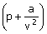v = RT, where a > 0. The final pressure
(a) will be slightly less than 5 bar (b) will be slightly more than 5 bar
(c) will be exactly 5 bar
(d) cannot be ascertained in the absence of the value of a

56. Heat flows through a composite slab, as shown below. The depth of the slab is 1 m. the k values are in W/m K. the overall thermal resistance in K/W is

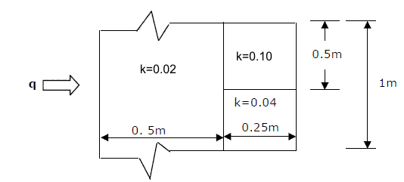
(a) 17.2 (b) 21.9 (c) 28.6 (d) 39.2

57. A small copper ball of 5 mm diameter at 500 K is dropped into an oil bath whose temperature is 300 K. the thermal conductivity of copper is 400 W/m.K, its density 9000 kg/m and its specific heat 385 J/kg. K. if the heat transfer 3 coefficient is 250 W/m² .K and lumped analysis is assumed to be valid, the rate of 2 fall of the temperature of the ball at the beginning of cooling will be, in K/s,
(a) 8.7 (b) 13.9 (c) 17.3 (d) 27.7

58. A solid cylinder (surface 2) is located at the center of a hollow sphere (surface 1). The diameter of the sphere is 1m, while the cylinder has a diameter and length of 0.5m each. The radiation configuration factor F₁₁ is
(a) 0.375 (b) 0.625 (c) 0.75 (d) 1

59. Hot oil is cooled from 80 to 50°C in an oil cooler which uses air as the coolant. The air temperature rises from 30 to 40°C.the designer uses a LMTD value of 26°C. the type of heat exchanger is
(a) parallel flow (b) double pipe
(c) counter flow (d) cross flow

60. The vapor compression refrigeration cycle is represented as shown in the figure below, with state 1 being the exit of the evaporator. The coordinate system used in this figure is
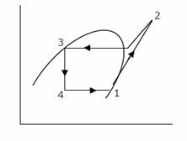

(a) p-h
(b) T-s
(c) p-s
(d) T-h
61. A vapor absorption refrigeration system is a heat pump with three thermal reservoirs as shown in the figure. A refrigeration effect of 100W is required at 250 K when the heat source available is at 400 K.Heat rejection occurs at 300 K. the minimum value of heat required (in W) is
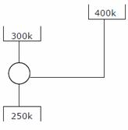
(a) 167 (b) 100
(c) 80 (d) 20

62. Various psychrometric processes are shown in the figure below.
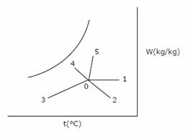
Process in Figure Name of the process
P. 0-1 i. Chemical dehumidification
Q. 0-2 ii. Sensible heating
R. 0-3 iii. Cooling and dehumidification
S. 0-4 iv. Humidification with steam injection
T. 0-5 v. Humidification with water injection
(a) P − i, Q − ii, R − iii, S − iv, T - v
(b) P − ii, Q − i, R − iii, S − v, T - iv
(c) P − ii, Q − i, R − iii, S − iv, T - v
(d) P − iii, Q − iv, R − v, S − i, T - ii
63. In the velocity diagram shown below, u = blade velocity, C = absolute fluid velocity and w = relative velocity of fluid and the subscripts 1 and 2 refer to inlet and outlet. This diagram is for

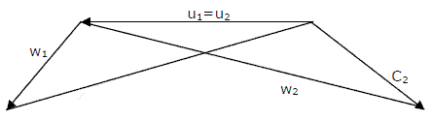

(a) an impulse turbine (b) a reaction turbine
(c) a centrifugal compressor (d) an axial flow compressor

64. A leaf is caught in a whirlpool. At a given instant, the leaf is at a distance of 120 m from the center of the whirlpool. The whirlpool can be described by the following velocity distribution: V_{r} = − 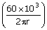 m/s and v₀ = 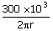 m/s , where r (in meters) is the distance from the center of the whirlpool. What will be the distance of the leaf from the center when it has moved through half a revolution?
(a) 48 m (b) 64 m (c) 120 m (d) 142 m

65. A mould has a downsprue whose length is 20 cm and the cross sectional area at the base of the downsprue is 1 cm² .The downsprue feeds a horizontal runner 2 leading into the mould cavity of volume 1000 cm³ .The time required to fill the 3 mould cavity will be
(a) 4.05 s (b) 5.05 s (c) 6.05 s (d) 7.25 s

66. A 2 mm thick metal sheet is to be bent at an angle of one radian with a bend radius of 100 mm. If the stretch factor is 0.5, the bend allowance is

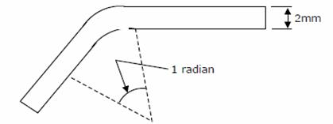

(a) 99 mm (b) 100 mm (c) 101 mm (d) 102 mm

67. Spot welding of two 1 mm thick sheets of steel (density = 8000 kg/m³ ) is carried out successfully by passing a certain amount of current for 0.1 second through the electrodes. The resultant weld nugget formed is 5 mm in diameter and 1.5 mm thick. If the latent heat of fusion of steel is 1400 kJ/kg and the effective resistance in the welding operation is 200 Ω, the current passing through the electrodes is approximately
(a) 1480 A (b) 3300 A (c) 4060 A (d) 9400 A

68. A 600 mm × 300 mm flat surface of a plate is to be finish machined on a shaper. The plate has been fixed with the 600 mm side along the tool travel direction. If the tool over-travel at each end of the plate is 20 mm, average cutting speed is 8 m/min, feed rate is 0.3 mm/stroke and the ratio of return time to cutting time of the tool is 1:2, the time required for machining will be
(a) 8 minutes (b) 12 minutes
(c) 16 minutes (d) 20 minutes

69. The tool of an NC machine has to move along a circular arc from (5,5) to (10,10) while performing an operation. The center of the arc is at (10,5). Which one of the following NC tool path commands performs the above mentioned operation?
(a) N010 G02 X10 Y10 X5 Y5 R5 (b) N010 G03 X10 Y10 X5 Y5 R5
(c) N010 G01 X5 Y5 X10 Y10 R5 (d) N010 G02 X5 Y5 X10 Y10 R5

70. A component can be produced by any of the four processes I, II, III and IV. Process I has a fixed cost of Rs.20 and variable cost of Rs.3 per piece. Process II has a fixed cost of Rs.50 and variable cost of Re.1 per piece. Process III has a fixed cost of Rs.40 and variable cost of Rs.2 per piece. Process IV has a fixed cost of Rs.10 and variable cost of Rs.4 per piece. If the company wishes to produce 100 pieces of the component, from economic point of view it should choose
(a) Process I (b) Process II (c) Process III (d) Process IV

71. A welding operation is time-studied during which a operator was pace-rated as 120%. The operator took, on an average, 8 minutes for producing the weld-joint. If a total of 10% allowances are allowed for this operation, the expected standard production rate of the weld-joint (in units per 8 hour day) is
(a) 45 (b) 50 (c) 55 (d) 60

72. The distribution of lead-time demand fro an item is as follows:
Lead time demand Probability
80 0.20
100 0.25
120 0.30
140 0.25
The reorder level is 1.25 times the expected value of the lead-time demand. The service level is
(a) 25% (b) 50% (c) 75% (d) 100%

73. A project has six activities (A to F) with respective activity durations 7, 5, 6, 6, 8, 4 days. The network has three paths A-B,C-D and E-F. All the activities can be crashed with the same crash cost per day. The number of activities that need to be crashed to reduce the project duration by 1 day is
(a) 1 (b) 2 (c) 3 (d) 6

74. A company has two factories S1, S2 and two warehouses D1, D2. the supplies from S1 and S2 are 50 and 40 units respectively. Warehouse D1 requires a minimum of 20 units and a maximum of 40 units. Warehouse D2 requires a minimum of 20 units and, over and above, it can take as much as can be
supplied. A balanced transportation problem is to be formulated for the above situation. The number of supply points, the number of demand points, and the total supply (or total demand) in the balanced transportation problem respectively are
(a) 2, 4, 90 (b) 2, 4, 110
(c) 3, 4, 90 (d) 3, 4, 110

75. Two tools P and Q have signatures 5⁰ − 5⁰ − 6⁰ − 8⁰ − 30⁰ − 0 and 5⁰ − 5⁰ − 7⁰ − 7⁰ − 8⁰ − 15⁰ − 0 both ASA) respectively. They are used to turn components under the same machining conditions. If h_{P} and h_{Q} denote the peak-to-valley heights of surfaces produced by the tools P and Q,
the ratio will be
(a) 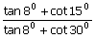 (b) 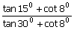
(c) 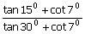 (d) 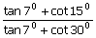

Common Data Questions
Common Data for Questions 76, 77, 78: An instantaneous configuration of a four-bar mechanism, whose plane is horizontal, is shown in the figure below. At this instant, the angular velocity and angular acceleration of link O₂A are ω =8rad/s and α =0, respectively, and the driving torque ( τ ) is zero. The link O₂A is balanced so that its center of mass falls at O₂ .

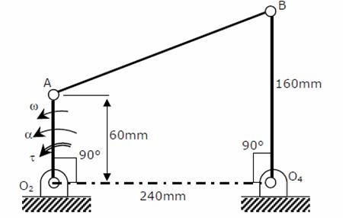

76. Which kind of 4-bar mechanism is O₂ABO₄ ?
(a) Double-crank mechanism (b) Crank-rocker mechanism
(c) Double-rocker mechanism (d) Parallelogram mechanism

77. At the instant considered, what is the magnitude of the angular velocity of O₄B ?
(a) 1 rad/s (b) 3 rad/s

(c) 8 rad/s (d) rad/s

78. At the same instant, if the component of the force at joint A along AB is 30 N, then the magnitude of the joint reaction at O₂
(a) is zero (b) is 30 N
(c) is 78 N (d) cannot be determined from the given data

Common Data for Questions 79, 80: In two air standard cycles - one operating on the Otto and the other on the Brayton cycle - air is isentropically compressed from 300 to 450 K. heat is added to raise the temperature to 600 K in the Otto cycle and to 550 K in the Brayton cycle.

79. If η₀and η_{B} are the efficiencies of the Otto and Brayton cycles, then
(a) η₀ = 0.25, η_{B} = 0.18 (b) η₀ = η_{B} = 0.33
(c) η₀ = 0.5, η_{B} = 0.45
(d) it is not possible to calculate the efficiencies unless the temperature after the expansion is given.

80. If W₀ and W_{B} work outputs per unit mass, then
(a) W₀> W_{B} (b) W₀< W_{B}
(c) W₀ = W_{B}
(d) it is not possible to calculate the work outputs unless the temperature after the expansion is given.

Linked Answer Questions: Q.81a to Q.85b carry two marks each.
Statement for Linked Answer Questions 81a & 81b: The complete solution for the ordinary differential equation 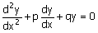is y = C₁e^{-x} +C₂e^{-3x}
81 (A) Then, p and q are
(a) p = 3, q = 3 (b) p = 3, q = 4
(c) p = 4, q =3 (d) p = 4, q = 4

(B) Which of the following is a solution of the differential equation
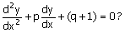
(a) e^{-3x} (b) xe^{-x} (c) xe^{-2x} (d) x²e^{-2x}

Statement for Linked Answer Questions 82a & 82b:
A band brake consists of a lever attached to one end of the band. The other end of the band is fixed to the ground. The wheel has a radius of 200 mm and the wrap angle of the band is 270°.The braking force applied to the lever is limited to 100N, and the coefficient of friction between the band and the wheel is 0.5. No other information is given.

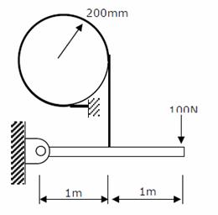

82. (A) The maximum tension that can be generated in the band during braking is
(a) 1200 N (b) 2110 N (c) 3224 N (d) 4420 N

(B) The maximum wheel torque that can be completely braked is
(a) 200 N.m (b) 382 N.m (c) 604 N.m (d) 844 N.m

Statement for Linked Answer Questions 83a & 83b: Consider a linear programming problem with two variables and two constraints. The objective function is: Maximize X₁ + X₂. The corner points of the feasible region are (0,0), (0,2), (2,0) and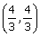,
83. (A) If an additional constraint X₁ + X₂ ≤ 5 is added, the optimal solution is
(a) 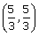 (b)
(c) 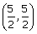 (d) (5,0)

(B) Let Y₁ and Y₂ be the decision variables of the dual and v₁ and v₂ be the slack variables of the dual of the given linear programming problem. The optimum dual variables are

(a) Y₁ and Y₂ (b) Y₁ and v₁
(c) Y₁ and v2 (d) v₁ and v₂

Statement for Linked Answer Questions 84a & 84b:
The following table of properties was printed out for saturated liquid and saturated vapour of ammonia. The titles for only the first two columns are available. All that we know is that the other columns (columns 3 to 8) contain data on specific properties, namely, internal energy (kJ/kg), enthalpy (kJ/kg) and entropy (kJ/kg.K).

T(°C) | P(kPa)
-20 | 190.2 | 88.76 | 0.3657 | 89.05 | 5.6155 | 1299.5 | 1418.0
0 | 429.6 | 179.69 | 0.7114 | 180.36 | 5.3309 | 1318.0 | 1442.2
20 | 857.5 | 272.89 | 1.0408 | 274.30 | 5.0860 | 1332.2 | 1460.2
40 | 1554.9 | 368.74 | 1.3574 | 371.43 | 4.8662 | 1341.0 | 1470.2

84. (A) The specific enthalpy data are in columns
(a) 3 and 7 (b) 3 and 8 (c) 5 and 7 (d) 5 and 8

(B) When saturated liquid at 40°C is throttled to -20°C, the quality at exit will be
(a) 0.189 (b) 0.212 (c) 0.231 (d) 0.788

Statement for Linked Answer Questions 85a & 85b: An un-insulated air conditioning duct of rectangular cross section 1 m × 0.5 m, carrying air at 20°C with a velocity of 10 m/s, is exposed to an ambient of 30°C.Neglect the effect of duct construction material. For air in the range of 20-30°C, data are as follows: thermal conductivity =0.025 W/m.K; viscosity = 18μ Pa.s; Print number =0.73; density = 1.2 kg/m³ . The laminar flow Nusselt number is 3.4 for constant wall temperature conditions 3 and, for turbulent flow, Nu=0.023 Re^{0.8}Pr^{0.33}.

85. (A) The Reynolds number for the flow is
(a) 444 (b) 890 (c) 4.44 × 10 (d) 5.33 × 10

(B) The heat transfer per metre length of the duct, in watts, is:
(a) 3.8 (b) 5.3 (c) 89 (d) 769

