GATE question papers: Electronics and Communication Engineering 2008 (EC)

Q. 1 to 20 Carry One Mark Each
1. All the four entries of the 2×2 matrix p = 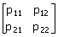 are nonzero, and one of its eigenvalues is zero. Which of the following statements is true?
(A) p₁₁ p₂₂ - p₁₂ p₂₁ = 1 (B) p₁₁ p₂₂ - p₁₂ p₂₁ = -1
(C) p₁₁ p₂₂₀ - p₁₂ p₂₁ = 0 (D) p₁₁ p₂₂ + p₁₂ p₂₁ = 0

2. The system of linear equations
4x + 2y = 7
2x + y = 6
has
(A) a unique solution (B) no solution
(C) an infinite number of solutions (D) exactly two distinct solutions

3. The equation sin (z) = 10has
(A) no real or complex solution (B) exactly two distinct complex solutions
(C) a unique solution (D) an infinite number of complex solutions

4. For real values of x, the minimum value of the function f (x) = exp (x) + exp (-x) is
(A) 2 (B) 1 (C) 0.5 (D) 0

5. Which of the following functions would have only odd powers of x in its Taylor series expansion about the point x=0?
(A) (3) sin x (B) (2) sin x (C) (3) cos x (D) (2) cos x

6. Which of the following is a solution to the differential equation 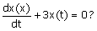
(A) x( t) = 3e^{-t} (B) x( t) = 3e^{-3t} (C) x( t) = 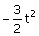 (D) x( t) = 3t²
7. In the following graph, the number of trees (P) and the number of cut-sets (Q) are
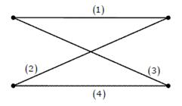
(A) P=2, Q=2
(B) P=2, Q=6
(C) P=4, Q=6
(D) P=4, Q=10
8. In the following circuit, the switch S is closed at t=0. The rate of change of current 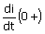is given by
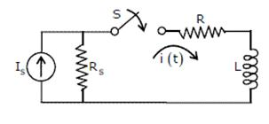
(A) 0
(B) 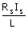
(C) 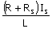
(D) ¥
9. The input and output of a continuous time system are respectively denoted by x(t) and y(t). Which of the following descriptions corresponds to a causal system?
(A) y (t) = x (t - 2) + x (t + 4) (B) y (t) = (t - 4) x (t + 1)
(C) y (t) = (t + 4) x (t - 1) (D) y (t) = (t + 5) x (t + 5)

10. The impulse response h (t) of a linear time-invariant continuous time system is described by h(t) = exp (at)u(t) + exp (bt)u(-t), where u(t) denotes the unit step function, and a and b are real constants. This system is stable if
(A) a is positive and b is positive (B) a is negative and b is negative
(C) a is positive and b is negative (D) a is negative and b is positive

11. The pole-zero plot given below corresponds to a

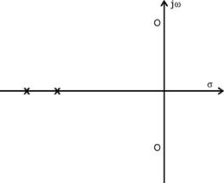

(A) Low pass filter (B) High pass filter
(C) Band pass filter (D) Notch filter

12. Step responses of a set of three second-order underdamped systems all have the same percentage overshoot. Which of the following diagrams represents the poles of the three systems?
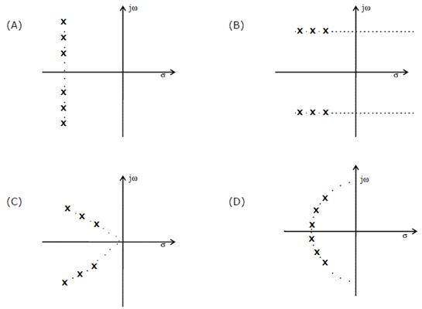

13. Which of the following is NOT associated with a p-n junction?
(A) Junction capacitance (B) Charge Storage Capacitance
(C) Depletion Capacitance (D) Channel Length Modulation

14. Which of the following is true?
(A) A silicon wafer heavily doped with boron is a p+ substrate
(B) A silicon wafer lightly doped with boron is a p+ substrate
(C) A silicon wafer heavily doped with arsenic is a p+ substrate
(D) A silicon wafer lightly doped with arsenic is a p+ substrate

15. For a Hertz dipole antenna, the half power beam width (HPBW) in the E-plane is
(A) 360° (B) 180° (C) 90° (D) 45°

16. For static electric and magnetic fields in an inhomogeneous source-free medium, which of the following represents the correct form of two of Maxwell’s equations?
(A) (B) (C) (D)

17. In the following limiter circuit, an input voltage V_{i} = 10sin100pt applied. Assume that the diode drop is 0.7V when it is forward biased. The Zener breakdown voltage is 6.8V.

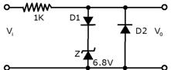

The maximum and minimum values of the output voltage respectively are

(A) 6.1V, - 0.7V (B) 0.7V, - 7.5V (C) 7.5V, - 0.7V (D) 7.5V, - 7.5V

18. A silicon wafer has 100nm of oxide on it and is inserted in a furnace at a temperature above 1000°C for further oxidation in dry oxygen. The oxidation rate
(A) is independent of current oxide thickness and temperature
(B) is independent of current oxide thickness but depends on temperature
(C) slows down as the oxide grows
(D) is zero as the existing oxide prevents further oxidation

19. The drain current of a MOSFET in saturation is given by where K is a constant. The magnitude of the transconductance gm is
(A) 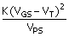 (B) 2K(V_{GS} - V_{T}) (C) 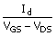 (D) 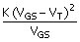

20. Consider the amplitude modulated (AM) signal A_{c} cos w_{c} t + 2cos w_{m} t cos w_{c} t. For demodulating the signal using envelope detector, the minimum value of Ac should be
(A) 2 (B) 1 (C) 0.5 (D) 0

Q. 21 to 75 carry two Marks Each

21. The Thevenin equivalent impedance Z_{th} between the nodes P and Q in the following circuit is

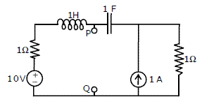
(A) 1 (B) 1 + s + (C) 2 + s + (D) 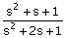

22. The driving point impedance of the following network

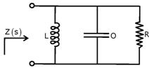
is given by Z (s ) =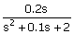. The component values are
(A) L = 5H, R = 0.5Ω, C = 0.1F (B) L = 0.1H, R = 0.5 Ω, C = 5F
(C) L = 5H, R = 2 Ω, C = 0.1F (D) L = 0.1H, R = 2 Ω, C = 5F

23. The circuit shown in the figure is used to charge the capacitor C alternately from two current sources as indicated. The switches S1 and S2 are mechanically coupled and connected as follows
For 2nT £ t < (2n + 1) T, (n = 0, 1, 2 ...) S1 to P1 and S2 to P2
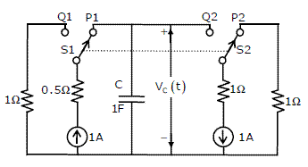

Assume that the capacitor has zero initial charge. Given that u (t) is a unit step function, the voltage V_{c} (t) across the capacitor is given be
(A) 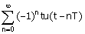 (B) u (t) + 2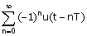
(C) tu(t) + 2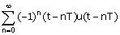 (D) 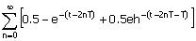

24. The probability density function (PDF) of a random variable X is as shown below

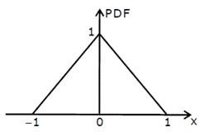

The corresponding cumulative distribution function (CDF) has the form
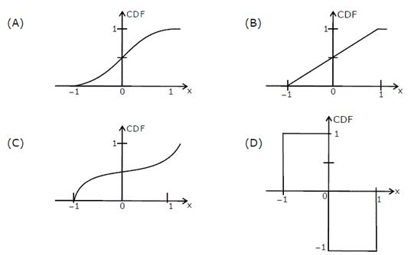

25. The recursion relation to solve x=e^{-x} using Newton Raphson method is
(A) x_{n+1} = (B) x_{n+1} = x_{n} -
(C) x_{n+1} = (1 + x _{n})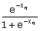 (D) x_{n+1} = 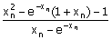

26. The residue of the function f(z) = 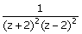 at z = 2 is
(A) 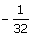 (B) 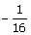 (C) (D)

27. Consider the matrix p = 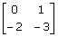 The value of e^{p} is
(A) 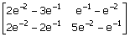 (B) 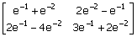

(C) 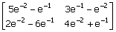 (D) 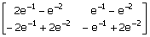

28. In the Taylor series expansion of exp(x) + sin(x) about the point x=p, the coefficient of (x - p )² is
(A) exp(p) (B) 0.5exp (p) (C) exp (p) + 1 (D) exp (p) - 1

29. P_{x} (x) = M exp (-2 |x| ) + Nexp (-3 |x| ) is the probability density function for the real random variable X, over the entire x axis. M and N are both positive real numbers. The equation relating M and N is
(A) M + N = 1 (B) 2M + N = 1 (C) M + N = 1 (D) M + N = 3

30. The value of the integral of the function g(x, y) = 4x³ + 10y⁴ along the straight line segment from the point (0, 0) to the point (1, 2) in the x-y plane is
(A) 33 (B) 35 (C) 40 (D) 56

31. A linear, time-invariant, causal continuous time system has a rational transfer function with simple poles at s=-2 and s=-4, and one simple zero at s=-1. A unit step u(t) is applied at the input of the system. At steady state, the output has constant value of 1. The impulse response of this system is
(A) [exp (-2t) + exp (-4t)] u(t)
(B) [-4exp (-2t) + 12 exp (-4t) - exp (-t)] u(t)
(C) [-4exp (-2t) + 12 exp (-4t)] u(t)
(D) [-0.5exp (-2t) + 1.5exp (-4t)] u(t)

32. The signal x(t) is described by
x(t) =
Two of the angular frequencies at which its Fourier transform becomes zero are
(A) p, 2p (B) 0.5p, 1.5p (C) 0, p (D) 2p, 2.5p

33. A discrete time linear shift-invariant system has an impulse response h[n] with h[0]=1, h[1]=-1. h[2]-2, and zero otherwise. The system is given an input sequence x[n] with x[0] – x[2] -1, and zero otherwise. The number of nonzero samples in the output sequence y[n], and the value of y[2] are, respectively
(A) 5, 2 (B) 6, 2 (C) 6, 1 (D) 5, 3

34. Consider points P and Q in the x-y plane, with P = (1, 0) and Q = (0, 1). The line integral 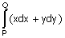 along the semicircle with the line segment PQ as its diameter
(A) is -1
(B) is 0
(C) is 1
(D) depends on the direction (clockwise or anti-clockwise) of the semicircle

35. Let x(t) be the input and y(t) be the output of a continuous time system. Match the system properties P1, P2 and P3 with system relations R1, R2, R3, R4.

Properties Relations

P1: Linear but NOT time-invariant R1: y (t) = t² x (t)
P2: Time-invariant but NOT linear R2: y (t) = t |x (t)|
P3: Linear and time-invariant R3: y (t) = |x (t)|
R4: y (t) = x (t - 5)
(A) (P1, R1), (P2, R3), (P3, R4) (B) (P1, R2), (P2, R3), (P3, R4)
(C) (P1, R3), (P2, R1), (P3, R2) (D) (P1, R1), (P2, R2), (P3, R3)

36. A memoryless source emits n symbols each with a probability p. The entropy of the source as a function of n
(A) increases as log n (B) decreases as log (1/n)
(C) increases as n (D) increases as n log n

37. {x(n)} is a real-valued periodic sequence with a period N. x(n) and X(k) form Npoint. Discrete Fourier Transform (DFT) pairs. The DFT Y (k) of the sequence
y(n) = 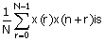
(A) |x (k)|² (B) 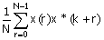
(C) 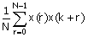 (D) 0

38. Group I lists a set of four transfer functions. Group II gives a list of possible step responses y(t). Match the step responses with the corresponding transfer functions
Group I
p = 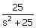 Q = 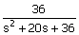 R = 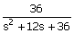 S = 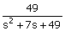
Group II
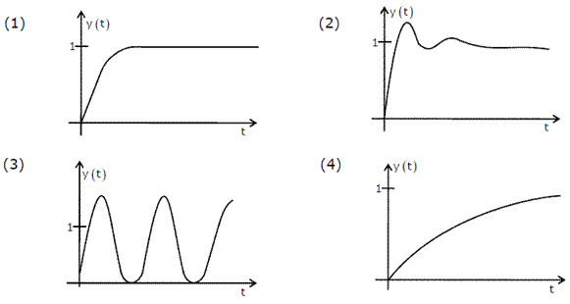

(A) P-3, Q-1, R-4, S-2 (B) P-3, Q-2, R-4, S-1
(C) P-2, Q-1, R-4, S-3 (D) P-3, Q-4, R-1, S-2

39. A certain system has transfer function G(s) =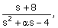a is a parameter. Consider the standard negative unity feedback configuration as shown below
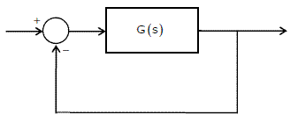

Which of the following statements is true?
(A) The closed loop system in never stable for any value of a
(B) For some positive values of a, the closed loop system is stable, but not for all positive values
(C) For all positive values of a, the closed loop system is stable
(D) The closed loop system is stable for all values of a, both positive and negative

40. A single flow graph of a system is given below
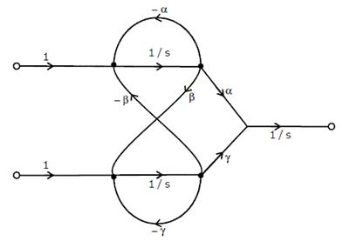
The set of equations that correspond to this signal flow graph is
(A) 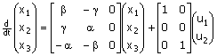

(B) 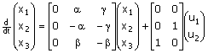

(C) 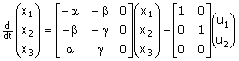

(D) 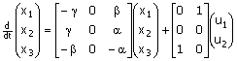

41. The number of open right half plane poles of G(s) 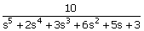is

(A) 0 (B) 1 (C) 2 (D) 3

42. The magnitude of frequency response of an underdamped second order system is 5 at 0rad/sec and peaks to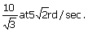The transfer function of the system is

(A) 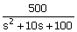 (B) 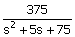

(C) 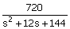 (D) 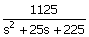

43. Group 1 gives two possible choices for the impedance Z in the diagram. The circuit elements in Z satisfy the condition R₂ C₂>R₁ C₁. The transfer function represents a kind of controller. Match the impedances in Group I with the types of controllers in Group II.
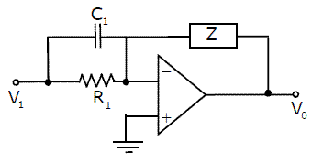

Group I Group II

P. 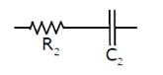 1. PID controller
2. Lead compensator
3. Lag compensator
Q. 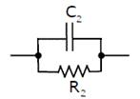

(A) Q - 1,R - 2 (B) Q - 1,R - 3 (C) Q - 2,R - 3 (D) Q - 3,R - 2

44. For the circuit shown in the following figure, transistors M1 and M2 are identical NMOS transistors. Assume that M2 is in saturation and the output is unloaded
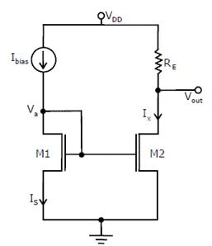

The current I_{x} is related to I_{bias} as
(A) I_{x} = I_{bias} + I_{s} (B) I_{x} = I_{bias}
(C) I_{x} = I_{bias} - I_{s} (D) I_{x} = I_{bias} -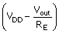

45. The measured transconductance g_{m} of an NMOS transistor operating in the linear region is plotted against the gate voltage V_{G} at constant drain voltage V_{D}. Which of the following figures represents the expected dependence of gm on V_{G}?
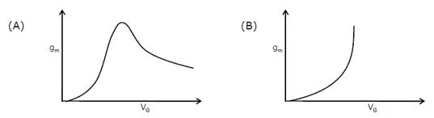

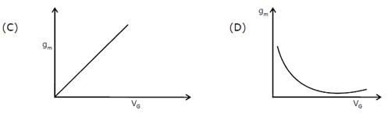

46. Consider the following circuit using an ideal OPAMP. The I-V characteristics of the diode is described by the relation I = I_{o}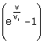 where V_{T} = 25mV, I₀ = 1mA and V is the voltage across the diode (taken as positive for forward bias).

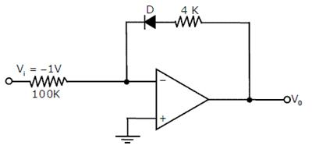

For an input voltage V₁ = -1V, the output voltage V₀ is

(A) 0 V (B) 0.1V (C) 0.7V 3(D) 1.1V

47.
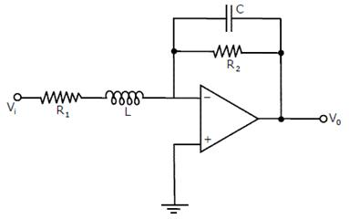

The OPAMP circuit shown above represents a
(A) high pass filter (B) low pass filter
(C) band pass filter (D) band reject filter
48. Two identical NMOS transistors M1 and M2 are connected as shown below. V_{bias} is chosen so that both transistors are in saturation. The equivalent g_{m} of the pair is defined to be 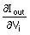at constant V_{out}.
The equivalent g_{m}'s of the pair is
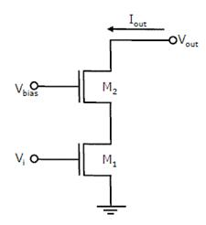
(A) The sum of individual g_{m}’s of the transistors
(B) The product of individual g_{m}’s of the transistors
(C) Nearly equal to the g_{m} of M1
(D) Nearly equal to g_{m} /g₀ of M2

49. An 8085 executes the following instructions
2710 LXI H, 30A0H
2713 DAD H
2714 PCHL
All addresses and constants are in Hex. Let PC be the contents of the program counter and HL be the contents of the HL register pair just after executing PCHL.
Which of the following statements is correct
(A) PC = 2715H (B) PC = 30A0H (C) PC = 6140H (D) PC = 6140H
HL = 30A0H HL = 2715H HL = 6140H HL = 2715H

50. An astable multivibrator circuit using IC 555 timer is shown below. Assume that the circuit is oscillating steadily
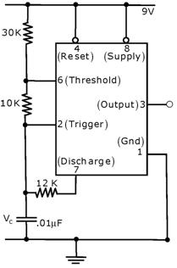
The voltage V_{c} across the capacitor varies between
(A) 3V to 5V (B) 3V to 6V (C) 3.6V to 6V (D) 3.6V to 5V

51. Silicon is doped with boron to a concentration of 4×10¹⁷ atoms/cm³. Assuming the intrinsic carrier concentration of silicon to be 1.5×10¹⁰/cm³ and the value of to be 25mV at 300K
Compared to undoped silicon, the Fermi level of doped silicon
(A) Goes down by 0.13eV (B) Goes up by 0.13eV
(C) Goes down by 0.427eV (D) Goes up by 0.427eV

52. The cross section of a JFET is shown in the following figure. Let V_{a} be -2V and let V_{p} be the initial pinch-off voltage. If the width W is doubled (with other geometrical parameters and doping levels remaining the same), then the ratio between the mutual transconductances of the initial and the modified JFET is
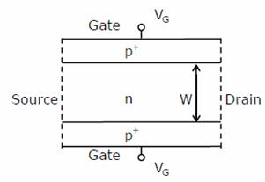
(A) 4 (B) 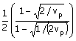
(C) 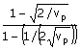 (D) 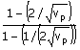

53. Consider the Schmidt trigger circuit shown below.

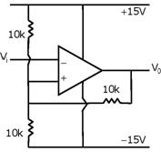

A triangular wave which goes from -12V to 12V is applied to the inverting input of the OPAMP. Assume that the output of the OPAMP sings from +15V to -15V. The voltage at the non-inverting input switches between
(A) -12V and +12V (B) -7.5V and +7.5V (C) -5V and +5V (D) 0V and 5V

54. The logic function implemented by the following circuit at the terminal OUT is
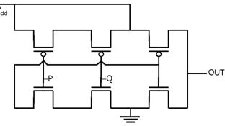
(A) P NOR Q (B) P NAND Q (C) P OR Q (D) P AND Q

55. Consider the following assertions
S1: For Zener effect to occur, a very abrupt junction is required
S2: For quantum tunneling to occur, a very narrow energy barrier is required
Which of the following is correct?
(A) Only S2 is true
(B) S1 and S2 are both true but S2 is not a reason for S1
(C) S1 and S2 are both true and S2 is a reason for S1
(D) Both S1 and S2 are false

56. The two numbers represented in signed 2’s complement form are P = 11101101 and Q = 11100110. If Q is subtracted from P, the value obtained in signed 2’s complement form is
(A) 100000111 (B) 00000111 (C) 11111001 (D) 111111001

57. Which of the following Boolean Expression correctly represents the relation between P, Q, R and M1?
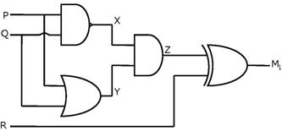

(A) M₁ = (P OR Q) XOR R
(B) M₁ = (P AND Q) XOR R
(C) M₁ = (P NOR Q) XOR R
(D) M₁ = (P XOR Q) XOR R

58. For the circuit shown in the following figure I₀-I₃ are inputs to the 4:1 multiplexer R(MSB) and S are control bits
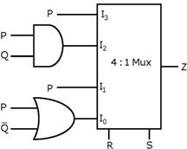

The output Z can be represented by
(A) PQ + PS +

(B) P + PQ +

(C) + QR + PQRS +

(D) PQ + PQR + PQS +

59. For each of the positive edge-triggered J-K flip flop used in the following figure, the propagation delay is DT
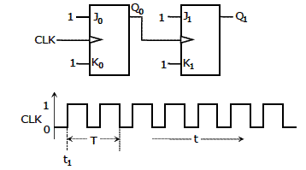

Which of the following waveforms correctly represents the output at Q₁?

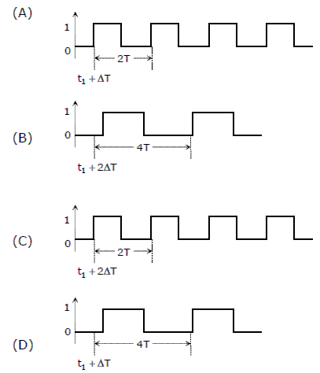

60. For the circuit shown in the figure, D has a transition from 0 to 1 after CLK changes from 1 to 0. Assume gate delays to be negligible
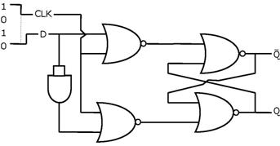
Which of the following statements is true?
(A) Q goes to 1 at the CLK transition and stays at 1
(B) Q goes to 0 at the CLK transition and stays at 0
(C) Q goes to 1 at the CLK transition and goes to 0 when D goes to 1
(D) Q goes to 0 at the CLK transition and goes to 1 when D goes to 1

61. A rectangular waveguide of internal dimensions (a = 4cm and b = 3) is to be operated in TE₁₁ mode. The minimum operating frequency is
(A) 6.25GHz (B) 6.0GHz (C) 5.0GHz (D) 3.75GHz

62. One of a loss-less transmission line having the characteristic impedance of 75Ω and length of 1cm is short-circuited. At 3GHz, the input impedance at the other end of the transmission line is
(A) 0 (B) Resistive (C) Capacitive (D) Inductive

63. A uniform plane wave in the free space is normally incident on an infinitely thick dielectric slab (dielectric constant e_{r} = 9). The magnitude of the reflection coefficient is
(A) 0 (B) 0.3 (C) 0.5 (D) 0.8

64. In the design of a single mode step index optical fiber close to upper cut-off, the single mode operations is NOT preserved if
(A) Radius as well as operating wavelength are halved
(B) Radius as well as operating wavelength are doubled
(C) Radius is halved and operating wavelength is doubled
(D) Radius is doubled and operating wavelength is halved

65. At 20GHz, the gain of a parabolic dish antenna of 1 meter diameter and 70% efficiency is
(A) 15dB (B) 25dB (C) 35dB (D) 45dB

66. Noise with double-sided power spectral density of K over all frequencies is passed through a RC low pass filter with 3dB cut-off frequency of f_{c}. The noise power at the filter output is
(A) K (B) Kf_{c} (C) Kpf_{c} (D) ¥

67. Consider a Binary Symmetric Channel (BSC) with probability of error being p. To transit a bit, say 1, we transmit a sequence of three 1s. The receiver will interpret the received sequence to represent 1 if at least two bits are 1. The probability that the transmitted bit will be received in error is
(A) p³ + 3p² (1 - p) (B) p³
(C) (1 - p)³ (D) p³ + p² (1 - p)

68. Four messages band limited to W, W, 2W and 3W respectively are to be multiplexed using Time Division Multiplexing (TDM). The minimum bandwidth required for transmission of this TDM signal is
(A) W (B) 3W (C) 6W (D) 7W

69. Consider the frequency modulated signal
10cos [2p ×10⁵ t + 5sin (2p ×1500t) + 7.5sin (2p ×1000t] with carrier frequency of 10⁵ Hz. The modulation index is
(A) 12.5 (B) 10 (C) 7.5 (D) 5

70. The signal cos w_{c} t + 0.5cos w_{m} t sinw_{c} t is
(A) FM only (B) AM only (C) both AM & FM (D) neither AM nor FM

Common Data Questions 71, 72 & 73

A speech signal, band limited to 4kHz and peak voltage varying between +5V and -5V is sampled at the Nyquist rate. Each sample is quantized and represented by 8 bits.

71. If the bits 0 and 1 are transmitted using bipolar pulses, the minimum bandwidth required for distortion free transmission is
(A) 64kHz (B) 32kHz (C) 8kHz (D) 4kHz

72. Assuming the signal to be uniformly distributed between its peak values, the signal to noise ratio at the quantizer output is
(A) 16dB (B) 32dB (C) 48dB (D) 64dB

73. The number of quantitization levels required to reduce the quantization noise by a factor of 4 would be
(A) 1024 (B) 512 (C) 256 (D) 64

Common Data Questions 74 & 75

The following series RLC circuit with zero initial conditions is excited by a unit impulse function d (t)

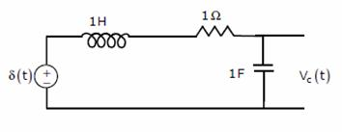
74. For t > 0, the output voltage V_{c} (t ) is
(A) 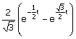 (B) 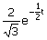
(C) cos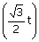 (D) sin

75. For t > 0, the voltage across the resistor is
(A) 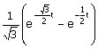 (B) 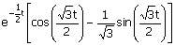
(C) sin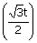 (D) cos

Linked Answer Questions: Q.76 to 85 Carry Two Marks Each

Statement for Linked Answer Questions: 76 & 77

A two-port network shown below is excited by external dc sources. The voltages and the currents are measured with voltmeters V₁, V₂ and ammeter A₁, A₂ (all assumed to be ideal), as indicated. Under following switch conditions, the readings obtained are:
i) S₁ - Open, S₂ - Closed A₁ = 0A, V₁ = 4.5V, V₂ = 1.5V, A₂ = 1A
ii) S₁ - Closed, S₂ - Open A₁ = 4A, V₁ = 6V, V₂ = 6V, A₂ = 0A

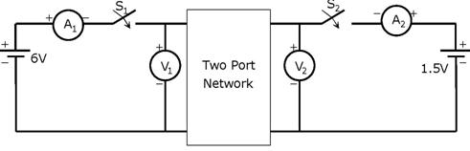
76. The z-parameter matrix for this network is
(A) 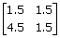 (B) 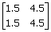 (C) 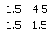 (D) 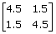

77. The h-parameter matrix for this network is
(A) 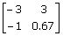 (B) 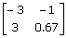 (C) 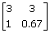 (D) 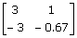

Statement for Linked Answer Questions: 78 & 79

In the following network, the switch is closed at t = 0- and the sampling starts from t = 0. The sampling frequency is 10Hz.

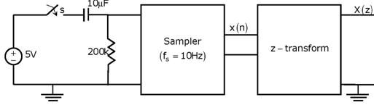
78. The samples x (n) (n = 0, 1, 2, ...) are given by
(A) 5 (1 - e^{-0.05n}) (B) 5e^{-0.05n} (C) 5 (1 - e^{-5n}) (D) 5e^{-5n}

79. The expression and the region of convergence of the z-transform of the sampled signal are
(A) 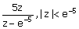 (B) 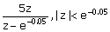
(C) 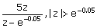 (D) 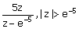

Statement for Linked Answer Questions: 80 & 81

In the following transistor circuit V_{BE} = 0.7V, r_{c} = 25mV / I_{E}, and b and all the capacitances are very large
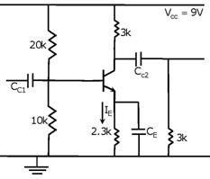

80. The value of DC current I_{E} is
(A) 1mA (B) 2mA (C) 5mA (D) 10mA

81. The mid-band voltage gain of the amplifier is approximately
(A) -180 (B) -120 (C) -90 (D) -60

Statement for Linked Answer Questions: 82 & 83

In the following circuit, the comparator output is logic “I” if V₁ > V₂ and is logic “0” otherwise. The D/A conversion is done as per the relations
V_{DAC} = 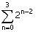volts, where b₃ (MSB), b₂, b₁ and b₀ (LSB) are the counter outputs the counter starts from the clear state
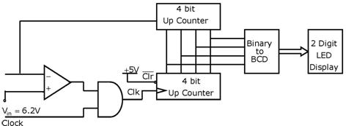

82. The stable reading of the LED display is
(A) 06 (B) 07 (C) 12 (D) 13

83. The magnitude of the error between V_{DAC} and V_{in} at steady state in volts is
(A) 0.2 (B) 0.3 (C) 0.5 (D) 1.0

Statement for Linked Answer Questions: 84 & 85

The impulse response h(t) of a linear time invariant continuous time system is given by h(t) = exp (-2t) u (t) , where u(t) denotes the unit step function

84. The frequency response H(w) of this system in terms of angular frequency w is given by H(w)
(A) 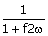 (B) 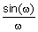 (C) 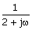 (D) 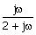

85. The output of this system to the sinusoidal input x (t) = 2cos (2t) for all time t, is
(A) 0 (B) 2^{-0.25} cos(2t - 0.125p)
(C) 2^{-0.5} cos(2t - 0.125p) (D) 2^{-0.5} cos(2t - 0.25p)
End of Question Paper

